Name

Mathematics Stage 5 Core
Quartiles and Box Plots

Book 1 | Determine quartiles and interquartile range  Represent datasets using box plots and use them to compare datasets | Version: 260706  Feedback:  https://MrDingMaths.com
Contents
Syllabus Content 2
Quartiles 3
Five-Number Summary and Interquartile Range 6
Box Plots 12
Box Plot Percentages 16
Comparing Datasets with Box Plots 19
Five-Number Summary from Stem-and-Leaf and Dot Plots 23
Five-Number Summary from Cumulative Histograms 27
Skewness of Box Plots 33

Syllabus Content
MA5-DAT-C-01 compares and analyses datasets using summary statistics and graphical representations
Determine quartiles and interquartile range
- Determine the 5-number summary for sets of numerical data
- Determine the 5-number summary from graphical representations
- Determine the interquartile range (IQR) for datasets
- Compare and explain the relative merits of range and IQR as measures of spread
Represent datasets using box plots and use them to compare datasets
- Represent numerical datasets using a box plot to display the median, upper and lower quartiles, and maximum and minimum values
- Compare 2 or more numerical datasets using parallel box plots drawn on the same scale
- Compare and contrast the centres, spreads and shapes of 2 or more numerical datasets, using box plots and numerical statistics, including the 5-number summary
- Determine quartiles from datasets displayed in histograms and dot plots, and represent these as a box plot
- Identify and describe skewness or symmetry of datasets displayed in histograms, dot plots and box plots
- Interpret box plots to draw conclusions and make inferences about the dataset

Quartiles

- Review
- Identify median from a list of numbers
- $2, 4, 5, 7, 9$ | - $1, 2, 3, 5, 7, 9$
- $5, 12, 7, 11, 4, 1, 7$ | - $12, 14, 14, 11, 10, 12, 13, 9$

- Quartiles
- Quartiles split ordered data into four equal groups.
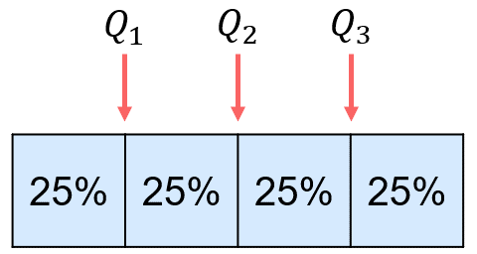

- $Q_{1}$ First quartile (lower quartile) 25% of data below this number
- $Q_{2}$ Second quartile (median) 50% of data below this number
- $Q_{3}$ Third quartile (upper quartile) 75% of data below this number

- Key Ideas
- Quartiles split a dataset into …………… equal groups
- The second quartile is also called the ……………; ……% of data is less than this number.
- The first quartile is also called the ………… quartile. 25% of data is less than this number.
- The third quartile is also called the ………… quartile. 75% of data is less than this number.

- Finding Quartiles
- $Q_{2}$: Find the median. The median splits the dataset into two halves.
- $Q_{1}$: Find the median of the lower half.
- $Q_{3}:$ Find the median of the upper half.

- Example Determine quartiles for a set of data
Find $Q_{1}$, $Q_{2}$ and $Q_{3}$ of the dataset:
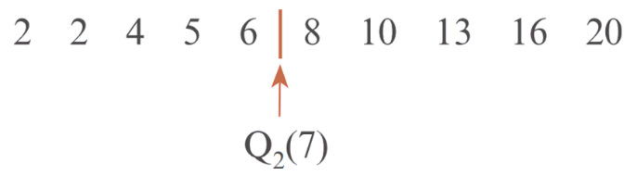
1. Find median $Q_{2}$

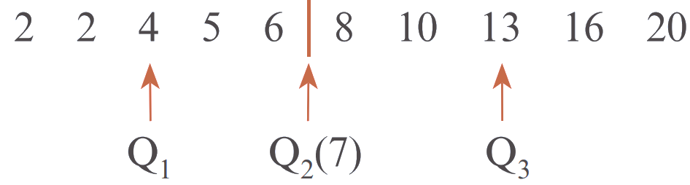
2. Find median of lower half ($Q_{1}$) and upper half $\left(Q_{3}\right)$

$Q_{1}$: 4 $Q_{2}$: 7 $Q_{3}$: 13

- Guided Practice
Find $Q_{1}$, $Q_{2}$ and $Q_{3}$ for these sets of data.
- 2 2 4 5 6 8 10 13 16 20  Q1 = 4, Q2 = 7, Q3 = 13 | - 1 1 2 2 3 4 4 5 6 7 18  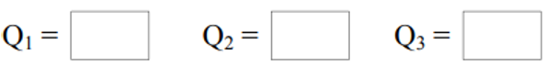  Q1 = 2, Q2 = 4, Q3 = 6

Foundation
- Calculate Q1, Q2, and Q3 for these datasets.
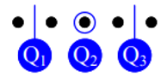  5 data values |   6 data values | 7 data values  
- 14, 20, 28, 36, 50  20, 28, 36 | - 5, 16, 25, 45, 45, 67  16, 35, 45 | - 9, 14, 16, 22, 22, 22, 31  14, 22, 22
- 8, 13, 18, 23, 37  13, 18, 23 | - 38, 48, 55, 75, 82, 93  48, 65, 82 | - 15, 33, 49, 57, 81, 93, 102  33, 57, 93
- 52, 64, 115, 144, 200  64, 115, 144 | - 18, 24, 86, 205, 312, 440  24, 145.5, 312 | - 9, 12, 41, 57, 82, 89, 128  12, 57, 89

  9 data values |   10 data values
- 1, 7, 12, 13, 16, 16, 19, 25, 28  9.5, 16, 22 | - 3, 5, 5, 8, 12, 12, 12, 14, 17, 19  5, 12, 14
- 19, 20, 42, 42, 57, 63, 66, 72, 77  31, 57, 69 | - 38, 46, 58, 62, 67, 73, 88, 88, 90, 94  58, 70, 88
- 88, 93, 99, 106, 108, 110, 110, 113, 119  96, 108, 111.5 | - 9, 12, 50, 73, 84, 99, 111, 118, 118, 133  50, 91.5, 118

Five-Number Summary and Interquartile Range

- Five-Number Summary and IQR
The five-number summary gives an overview of the data
Five-number Summary
Min | $$Q_{1}$$ | $$Q_{2}$$ | $$Q_{3}$$ | Max

Outliers greatly affect range and standard deviation.
The interquartile range (IQR) is the distance between Q3 and Q1.
It measures spread with less impact from outliers.
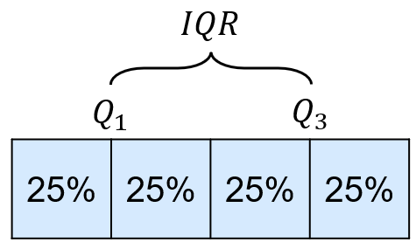

$$IQR=Q_{3}-Q_{1}$$

- Calculate Interquartile range
Calculate IQR
- $Q_{1}$ = 12, $Q_{3}$ = 27 | - $Q_{1}$ = 34, $Q_{3}$ = 61
- $Q_{3}$ = 85, $Q_{1}$= 49 | - $Q_{3}$ = 103, $Q_{1}$ = 78
- $Q_{1}$ = 15, $Q_{2}$ = 32, $Q_{3}$ = 54,  min = 8, max = 71 | - min = 44, $Q_{3}$ = 130, $Q_{2}$ = 89,  max = 156, $Q_{1}$ = 67

- Example Determine the five-number summary and IQR for a set of data
Determine the five-number summary and interquartile range of the dataset:

Min: 2 | $Q_{1}:$ 4 | $Q_{2}:$ 7 | $Q_{3}:$ 13 | Max: 20

$IQR=Q_{3}-Q_{1}$
$=13-4=9$

- Guided Practice
Calculate the five-number summary and interquartile range (IQR) for these sets of data
- 21 22 22 23 25 26 45  $IQR= Q_{3} - Q_{1}$  $=$ …… $-$ ……  $=$ ………  FNS: 21, 22, 23, 26, 45 | IQR = 4 | - 3 18 23 23 27 29 30 34  $IQR= Q_{3} - Q_{1}$  $=$ …… $-$ ……  $=$ ………  FNS: 3, 20.5, 25, 29.5, 34 | IQR = 9
  Min: | $Q_{1}:$ | $Q_{2}:$ | $Q_{3}:$ | Max:
  Min: | $Q_{1}:$ | $Q_{2}:$ | $Q_{3}:$ | Max:

- Key Ideas
- The five number summary gives an overview of the data: ……, ……, ……, ……, ……
- The ……………………… …………… is a measure of spread. It is less affected by ……………… when compared to the range

Foundation
- Calculate the five-number summary and IQR of the data set.
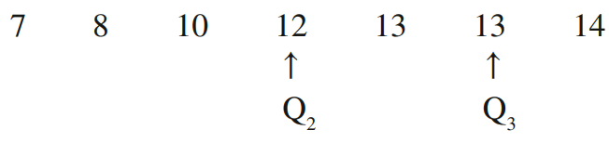

$$Min: 7, Q_{1}: 8, Q_{2}: 12, Q_{3}: 13, Max: 14$$  $$IQR = 13 - 8 = 5$$ | $IQR=Q_{3}-Q_{1}$  $=$ …… $-$ ……  $=$ ………
  Min: | $Q_{1}:$ | $Q_{2}:$ | $Q_{3}:$ | Max:
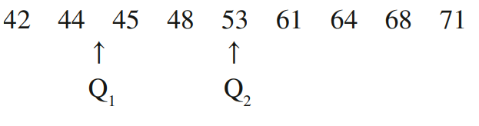

$$Min: 42, Q_{1}: 44, Q_{2}: 53, Q_{3}: 64, Max: 71$$  $$IQR = 64 - 44 = 20$$ | $IQR=Q_{3}-Q_{1}$  $=$ …… $-$ ……  $=$ ………
  Min: | $Q_{1}:$ | $Q_{2}:$ | $Q_{3}:$ | Max:
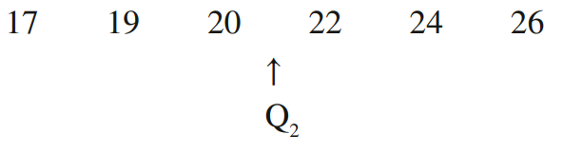

$$Min: 17, Q_{1}: 19, Q_{2}: 21, Q_{3}: 24, Max: 26$$  $$IQR = 24 - 19 = 5$$ | $IQR=Q_{3}-Q_{1}$  $=$ …… $-$ ……  $=$ ………
  Min: | $Q_{1}:$ | $Q_{2}:$ | $Q_{3}:$ | Max:
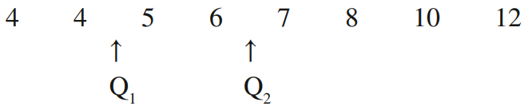

$$Min: 4, Q_{1}: 4.5, Q_{2}: 6.5, Q_{3}: 9, Max: 12$$  $$IQR = 9 - 4.5 = 4.5$$ | $IQR=Q_{3}-Q_{1}$  $=$ …… $-$ ……  $=$ ………
  Min: | $Q_{1}:$ | $Q_{2}:$ | $Q_{3}:$ | Max:

Development
- This ordered data set shows the number of hours of sleep 11 people had the night before.
3 5 5 6 7 7 7 8 8 8 9

  - Find the range
6
  - Find the median
7
  - Disregard the median then find the:
    - lower quartile
5
    - upper quartile
8
  - Find the interquartile range
3

- This ordered data set shows the number of fish Daniel caught in the 12 weekends that he went fishing during the year.
1 2 3 3 4 4 6 7 7 9 11 13

  - Find the range
12
  - Find the median
5
  - Split the data in half then find the:
    - lower quartile
3
    - upper quartile
8
  - Find the interquartile range
5

- Find the 5 number summary and IQR for each of these sets of data.
  - 1 3 4 7 9 10 11

$Min: 1, Q_{1}: 3, Q_{2}: 7, Q_{3}: 10, Max: 11$
$$IQR = 10 - 3 = 7$$
  - 14 14 15 16 16 18 19 19 20 20 21

$Min: 14, Q_{1}: 15, Q_{2}: 18, Q_{3}: 20, Max: 21$
$$IQR = 20 - 15 = 5$$
  - 0 1 2 3 5 5 6 7 7 8 9 9 11

$Min: 0, Q_{1}: 2.5, Q_{2}: 6, Q_{3}: 8.5, Max: 11$
$$IQR = 8.5 - 2.5 = 6$$
  - 18 21 21 26 27 29 30 30 35 36 37 38 41

$$Min: 18, Q_{1}: 23.5, Q_{2}: 30, Q_{3}: 36.5, Max: 41$$
$$IQR = 36.5 - 23.5 = 13$$

- Find the 5 number summary and IQR for each of these sets of data.
  - 35 11 26 45 22 36 53 38 40 19

$$Min: 11, Q_{1}: 22, Q_{2}:\frac{35 + 36}{2}= 35.5, Q_{3}: 40, Max: 53$$
$$IQR = 40 - 22 = 18$$
  - 108 117 94 103 125 107 129 105 100

$$Min: 94, Q_{1}: 101.5, Q_{2}: 107, Q_{3}: 121, Max: 129$$
$$IQR = 121 - 101.5 = 19.5$$
  - 17 11 8 15 3 14 10 12 7 19 15 16

$$Min: 3, Q_{1}: 9, Q_{2}:\frac{12 + 14}{2}= 13, Q_{3}: 15.5, Max: 19$$
$$IQR = 15.5 - 9 = 6.5$$

- Consider the scores 2, 3, 4, 5, 5, 5, 6, 7, 8.
A score of 23 is added to the dataset. How will this affect the IQR?

IQR is unchanged, remains at 3.
Hence, describe why the IQR is more useful than the range when there are outliers.

The range increases from 6 to 21. The IQR is more useful because it measures spread of the middle 50% of data, so outliers do not affect it.

- 2016 HSC Standard 2 Band 5
A referee wrote down the number of goals scored in 9 different games during the season.
2, 3, 3, 3, 5, 5, 8, 9, ...
The last number has been omitted. The range of the data is 10.
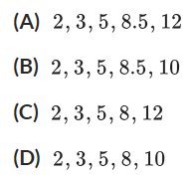
What is the five-number summary for this data set?

Max is 2 + 10 =12
Full list: 2 3 3 3 5 5 8 9 12
Answer is A

- 2007 HSC Standard 2 Band 5
This set of data is arranged in order from smallest to largest.
5 6 11 $x$ 13 18 25

The range is six less than twice the value of $x$
Which one of the following is true?
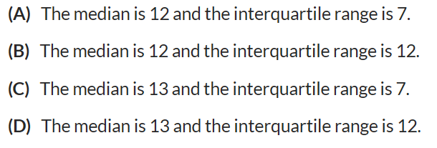
Range is 20
Range is $2x-6=20$
$$x=13$$
Dataset: 5 6 11 13 13 18 25
Answer is D

Box Plots

- Box Plots
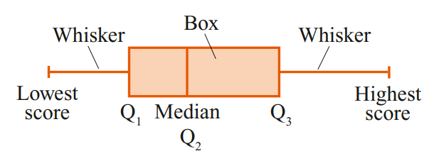
Box plots show the five number summary visually.

- Example Interpret box plots
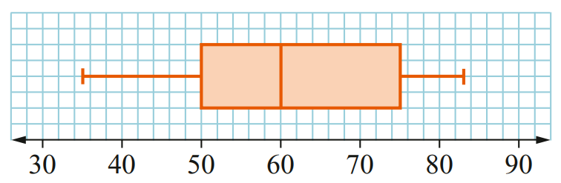
A dataset of student test scores is presented as a box plot.
Determine the five-number summary and IQR.

Min:  35 | $Q_{1}:$  50 | $Q_{2}:$  60 | $Q_{3}:$  75 | Max:  83

$$IQR=Q_{3}-Q_{1}=75-50=25$$

- Guided Practice
Interpret these box plots.
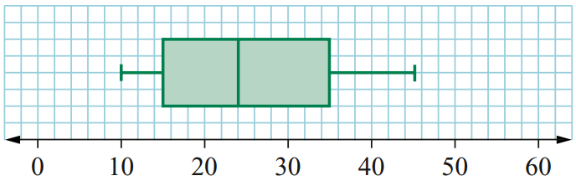  $IQR=$ …………………  FNS: 10, 15, 24, 35, 45 | IQR = 20 | 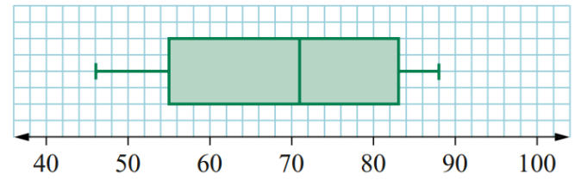  $IQR=$ …………………  FNS: 46, 55, 71, 83, 88 | IQR = 28
  Min: | $Q_{1}:$ | $Q_{2}:$ | $Q_{3}:$ | Max:
  Min: | $Q_{1}:$ | $Q_{2}:$ | $Q_{3}:$ | Max:
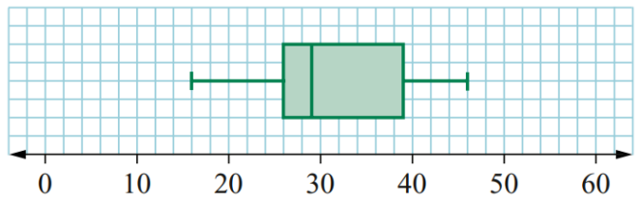  $IQR=$ …………………  FNS: 16, 26, 29, 39, 46 | IQR = 13 | 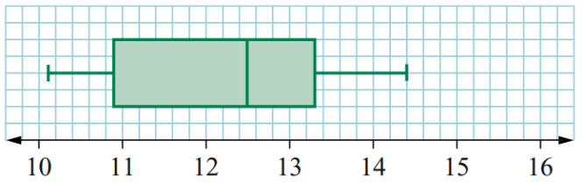  $IQR=$ …………………  FNS: 10.1, 10.9, 12.5, 13.3, 14.4 | IQR = 2.4
  Min: | $Q_{1}:$ | $Q_{2}:$ | $Q_{3}:$ | Max:
  Min: | $Q_{1}:$ | $Q_{2}:$ | $Q_{3}:$ | Max:

Foundation
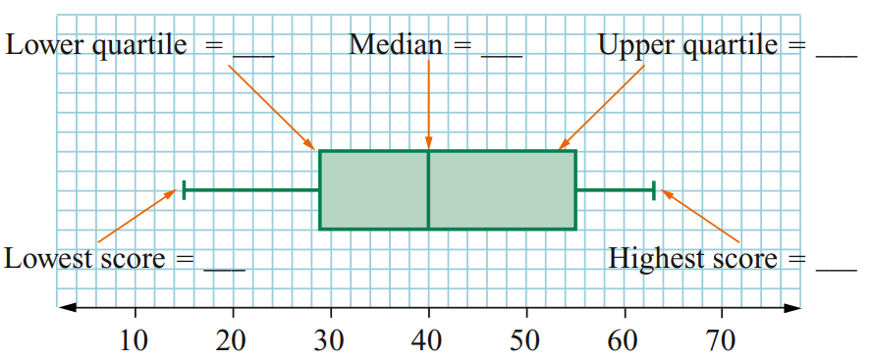
- Interpret this box plot.

Five number summary: 15, 29, 40, 55, 63
- Complete the following then draw the box plot.
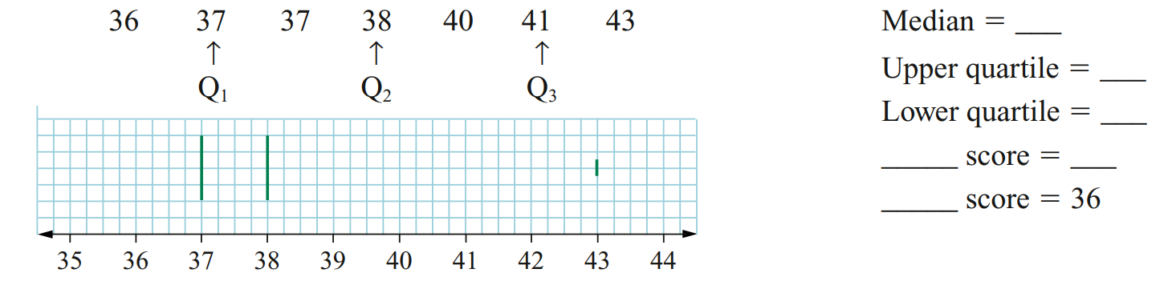
38
41
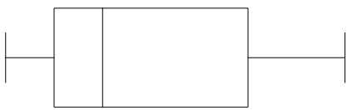
37
Max 43
Min 36

- Interpret these box plots.
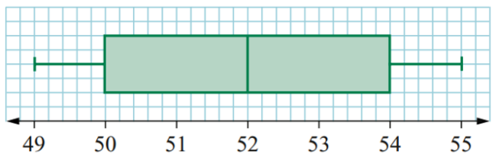  49, 50, 52, 54, 55  $IQR=$ …………………  4 | 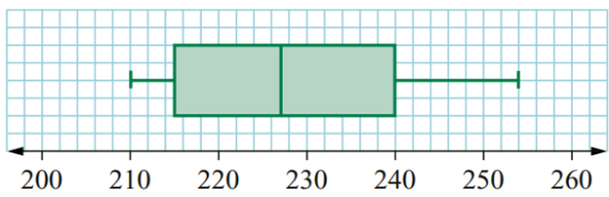  FNS: 210, 215, 227, 240, 254  IQR: 25
  Min: | $Q_{1}:$ | $Q_{2}:$ | $Q_{3}:$ | Max:
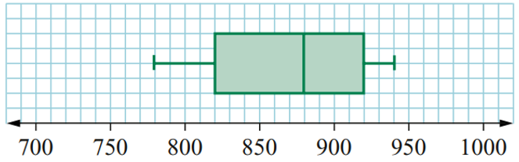  FNS: 780, 820, 880, 920, 940  IQR: 100 | 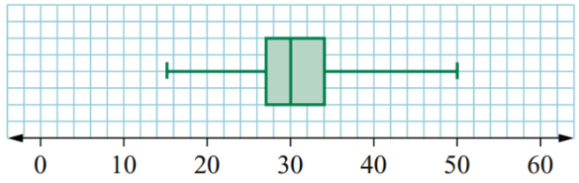  FNS: 15, 27, 30, 34, 50  IQR: 7

Development
- Fill in the table based on the diagram.
 | Median | Range | IQR
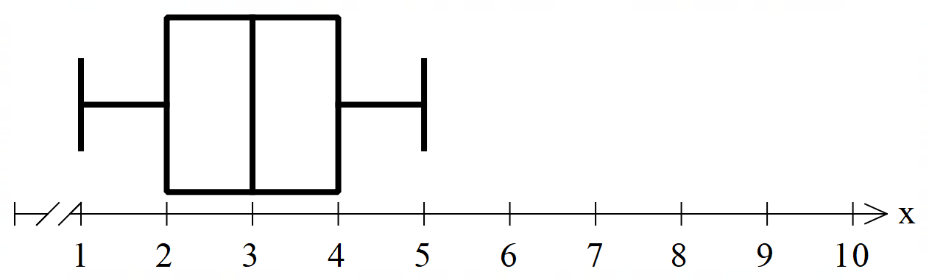 | 3 | 4 | 2
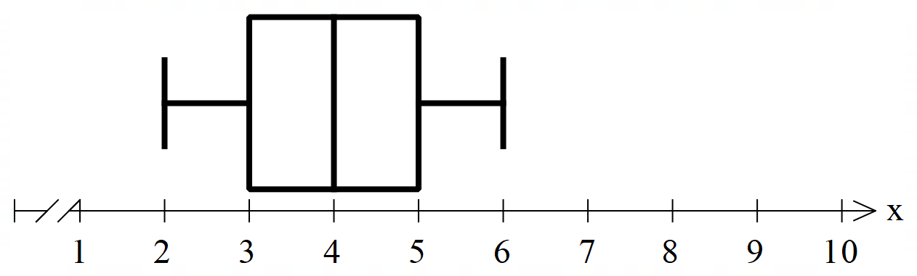 | 4 | 4 | 2
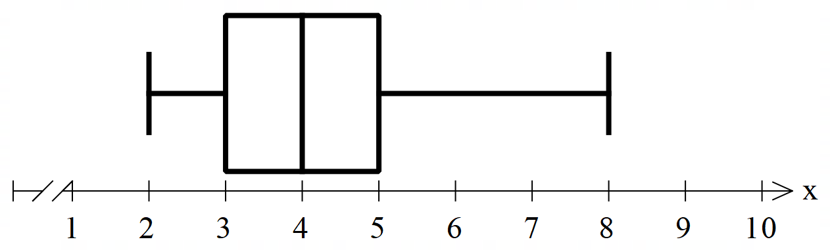 | 4 | 6 | 2
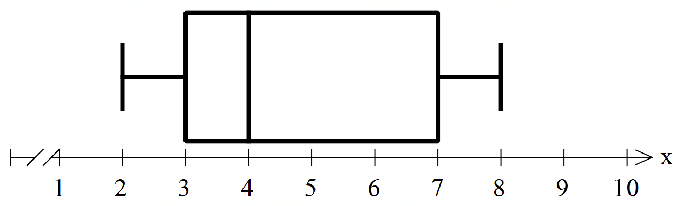 | 4 | 6 | 4
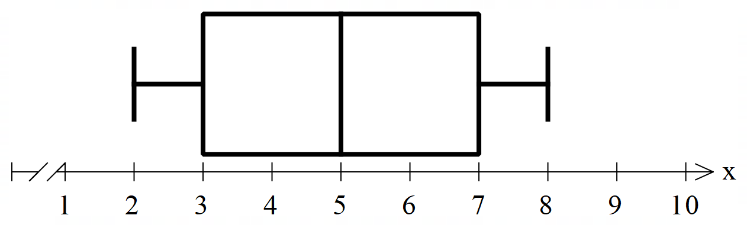 | 5 | 6 | 4
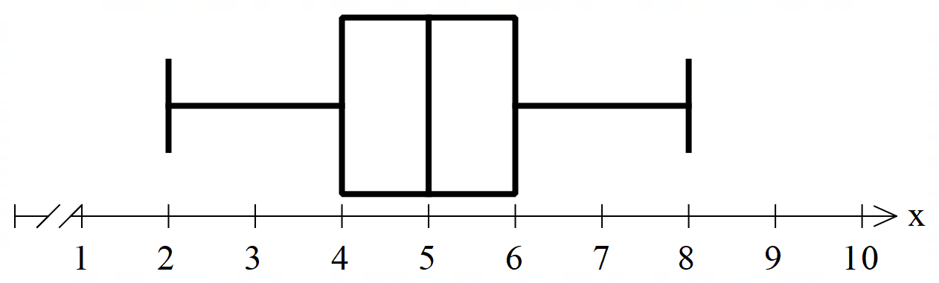 | 5 | 6 | 2
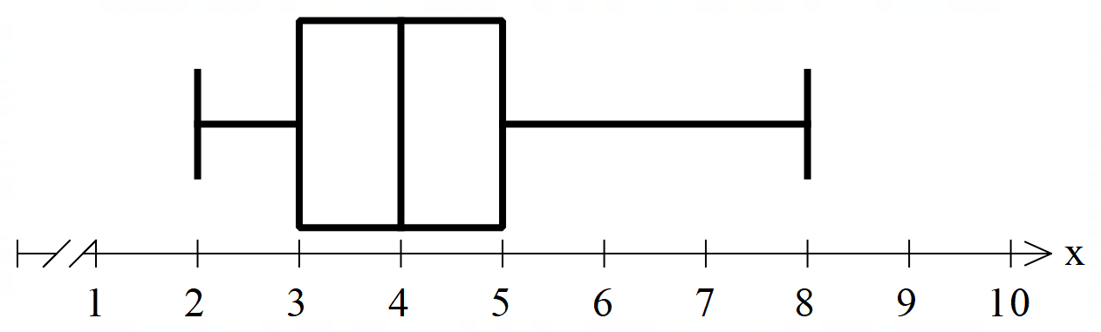 | 4 | 6 | 2
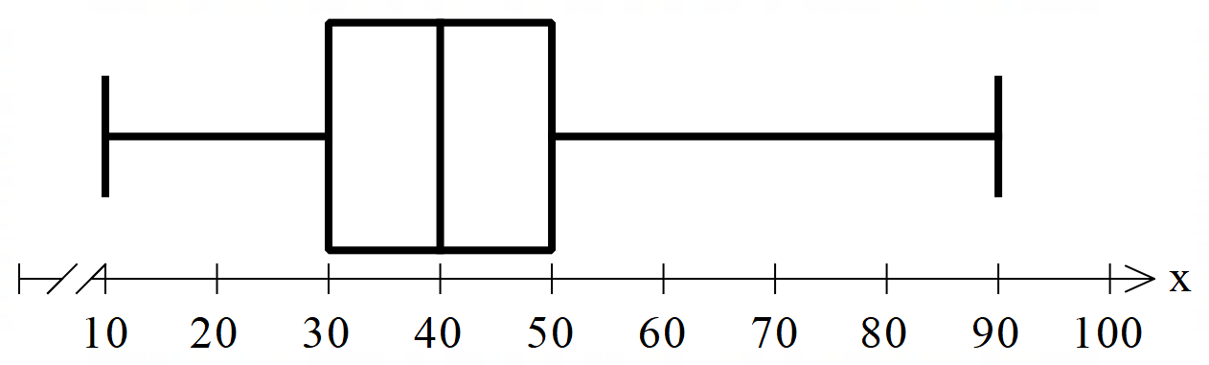 | 40 | 80 | 20

- Draw box plots for these five number summaries.
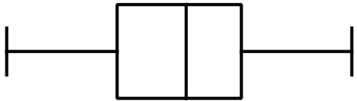  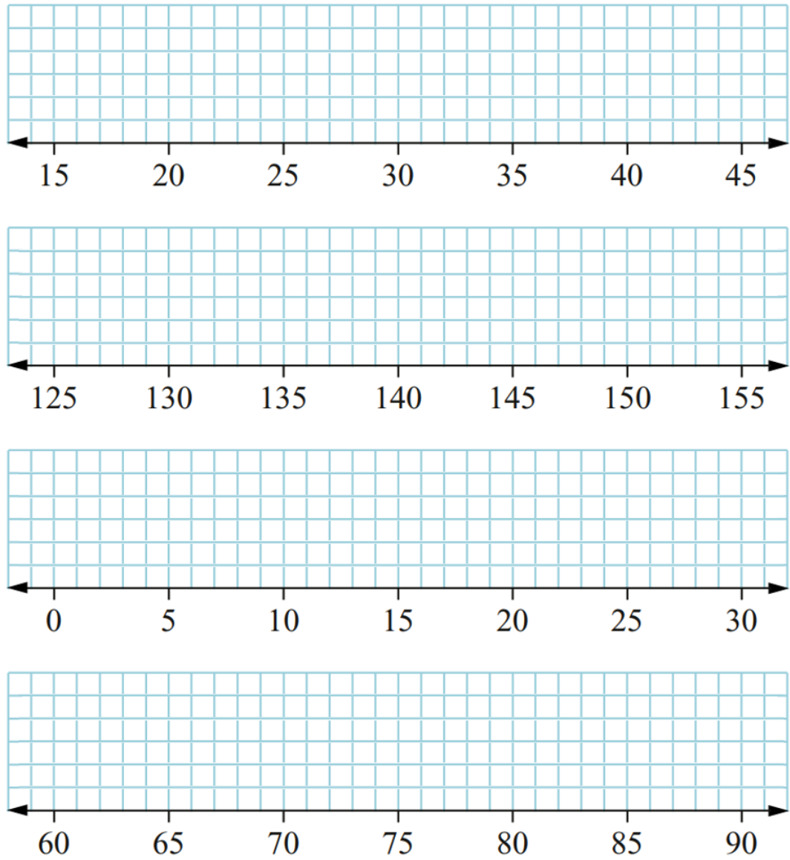 | 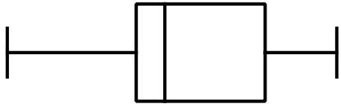
  Min | $$Q_{1}$$ | $$Q_{2}$$ | $$Q_{3}$$ | Max
  15 | 23 | 28 | 32 | 40
  Min | $$Q_{1}$$ | $$Q_{2}$$ | $$Q_{3}$$ | Max
  130 | 139 | 141 | 148 | 153
 | 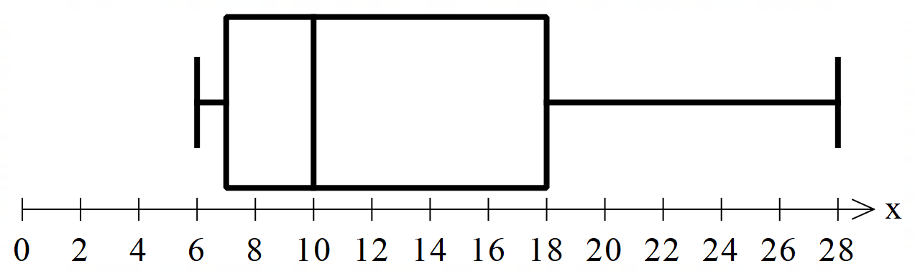  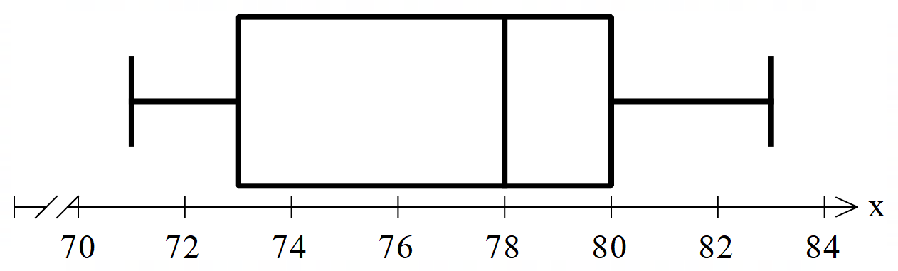
  Min | $$Q_{1}$$ | $$Q_{2}$$ | $$Q_{3}$$ | Max
  6 | 7 | 10 | 18 | 28
  Min | $$Q_{1}$$ | $$Q_{2}$$ | $$Q_{3}$$ | Max
  71 | 73 | 78 | 80 | 83

- State the five number summary of these datasets and draw the box plot.
- 34 35 36 36 37 38 39 39 39 40  34, 36, 37.5, 39, 40  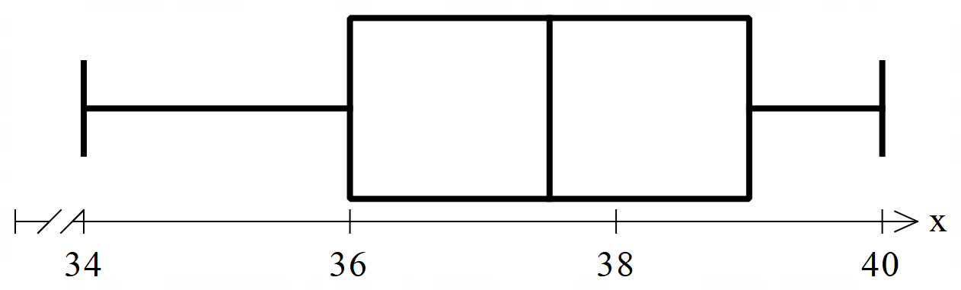 | - 4 5 8 8 10 12 12 14 15 19  4, 8, 11, 14, 19  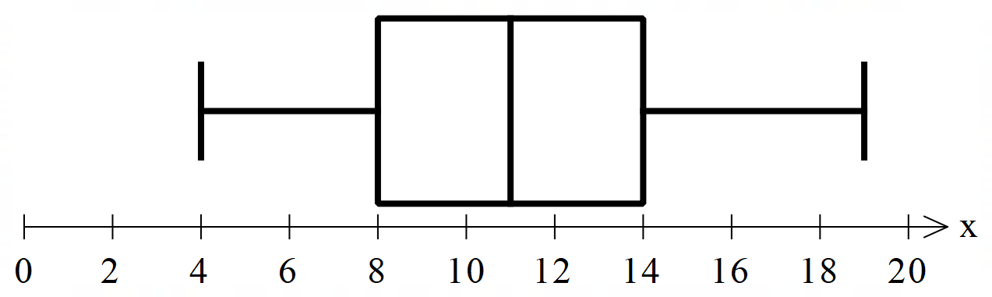
  Min: | $Q_{1}:$ | $Q_{2}:$ | $Q_{3}:$ | Max:
  Min: | $Q_{1}:$ | $Q_{2}:$ | $Q_{3}:$ | Max:

Box Plot Percentages

- Review
- Find percentage of a quantity
- Find 25% of 200. | - Find 50% of 470.
- Find 75% of 120. | - Find 25% of 164.
- Find 50% of 96. | - Find 75% of 360.

- Box Plot Percentages
Since a box plot shows quartiles, each part of the box plot is 25% of the dataset.
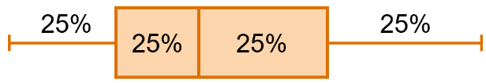

- Example Interpret box plots
200 students took a test.  Their scores are presented as a box plot. | - Between which two scores is the middle 50% of data?  50 and 75  - What proportion of people scored greater than 50?  75%  - How many people scored more than 50?  $200×0.75$ $=150$

- Guided Practice
The box plot shows how long 500 girls spent watching TV last week, in minutes.
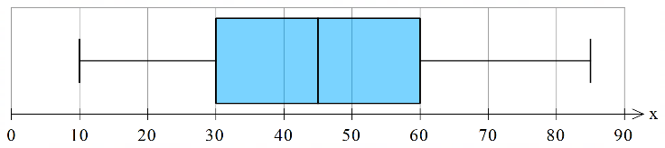

- Between which two scores is the middle 50% of data?
30 and 60
- What percentage watched between 60 and 85 minutes?
25%
- How many girls watched less than 60 minutes?
375

Foundation
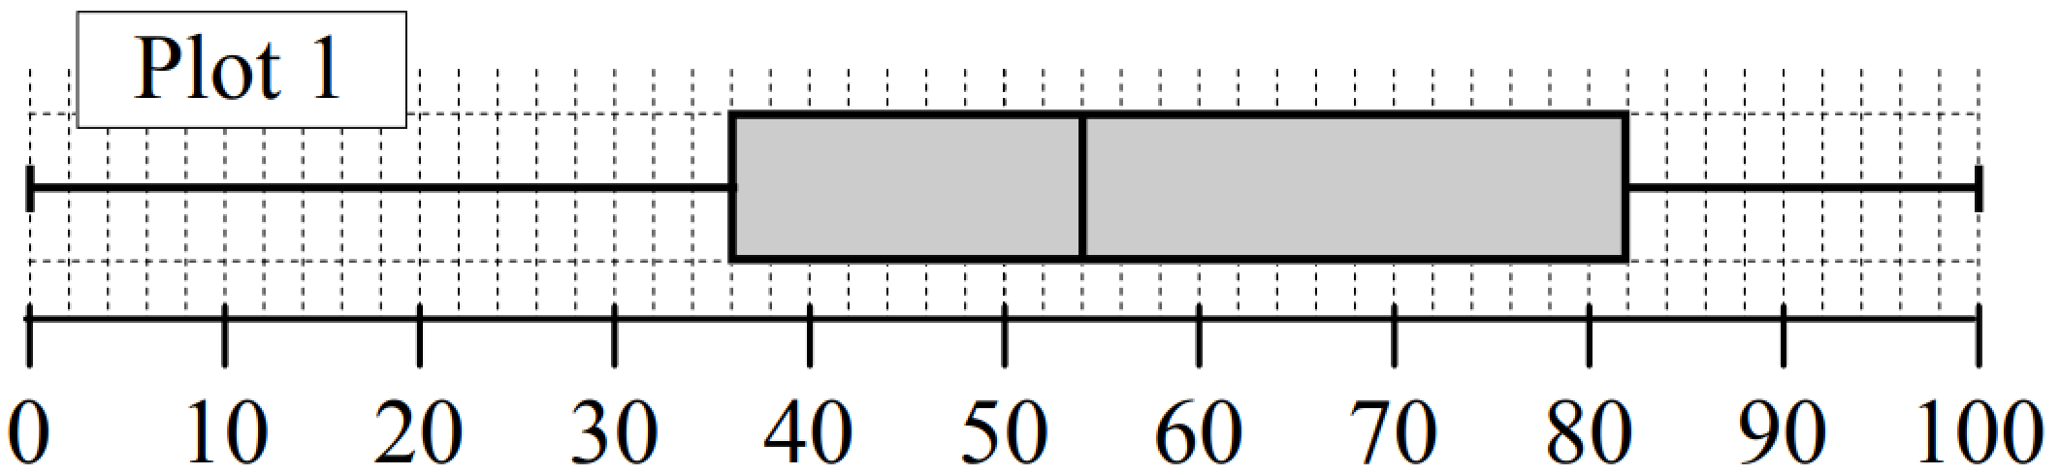
- Answer these questions using the box and whisker diagram.

  - The lowest 25% is between 0 and ………
36
  - The upper 25% is between ……… and ………
82 and 100
  - The middle 50% is between ……… and ………
36 and 82
  - The lower 50% is between ……… and ………
0 and 54
  - The upper 50% is between ……… and ………
54 and 100
What percentage of scores lie between:
- 54 and 82?  25% | - 36 and 100?  75% | - 0 and 54?  50% | - 36 and 82?  50%
If the box plot represents 86 000 people, how many are between:
- 0 and 36?  21500 | - 36 and 82?  43000 | - 0 and 82?  64500 | - 54 and 82?  21500

- This box plot represents people living in a retirement complex.
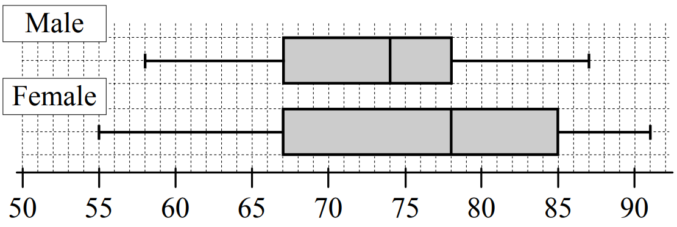
  - What percentage of male retirees are
aged between:
    - 58 and 67?
25%
    - 74 and 87?
50%
  - What percentage of female retirees
are aged between:
    - 55 and 85?
75%
    - 67 and 78?
25%
  - If there are 432 males and 584 females, how many:
    - Females are aged between 67 and 85?
292
    - Males are aged between 67 and 78?
216
    - Females are aged between 67 and 78?
146
    - Retirees in total aged between 67 and 78?
216 + 146 = 362

Development
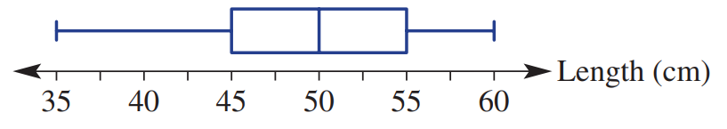
- This box plot summarises the length of babies born in a particular week in a hospital.

  - State the minimum and maximum baby lengths.
35, 60 cm
  - Find the range of the length of the babies.
25 cm
  - State the median baby length.
50 cm
  - Find the interquartile range.
10
  - 50% of the baby lengths are below what amount?
50 cm
  - 25% of the babies are born longer than what amount?
55 cm
  - If there were 80 babies born in the week,
how many would be expected to be less than 45 cm in length?
20

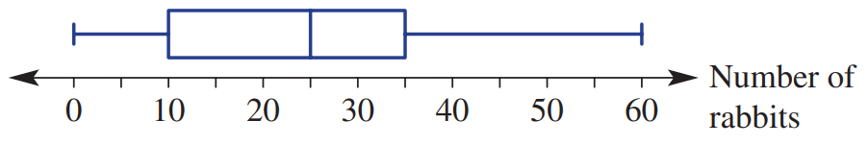
- This box plot show the number of rabbits spotted per day in a paddock over a 100-day period.

  - State the minimum and maximum rabbits spotted.
0, 60
  - Find the range of the number of rabbits spotted.
60
  - State the median number of rabbits spotted.
25
  - Find the interquartile range.
25
  - In 75% of the days, the number of rabbits spotted is below what amount?
35
  - In 75% of the days, the number of rabbits spotted is more than what amount?
10
  - How many days was the number of spotted rabbits less than 10?
25 days

Comparing Datasets with Box Plots

- Comparing Datasets using Parallel Box Plots
Box plots placed side by side allow for quick comparison of two datasets.
A higher median is generally better.
A smaller IQR means more consistent.

- Example Compare datasets using parallel box plots
Two datasets are shown.
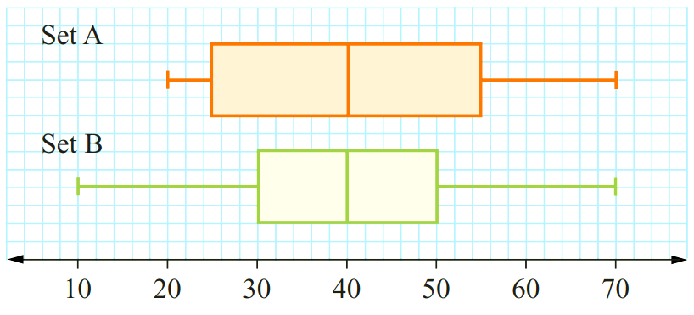
Describe the similarities.
Same median and same maximum value.
Which dataset has a larger range?
Set B has a larger range
Which dataset has a larger interquartile range?
Set A has the larger IQR

- Guided Practice
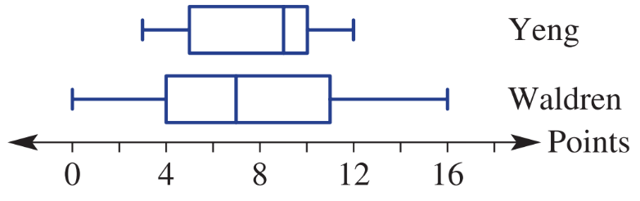
The number of points per game for two basketball players over a season is summarised in these box plots.

  - Which player has the higher maximum?
Waldren
  - Which player has the higher median?
Yeng
  - Which player has the smaller IQR?
Yeng
  - Which player is a more consistent basketball scorer? Give reasons.

Yeng, as he has a smaller range and IQR.

- Key Ideas
- The dataset with the higher ‘average’ has a higher ………………………
- The dataset that is more consistent has a smaller ……………………………………

Foundation
- A class has eight assessment tasks over a year. The parallel box plots show a summary of the marks for the assessments for two students, Jamie and Maryanne.
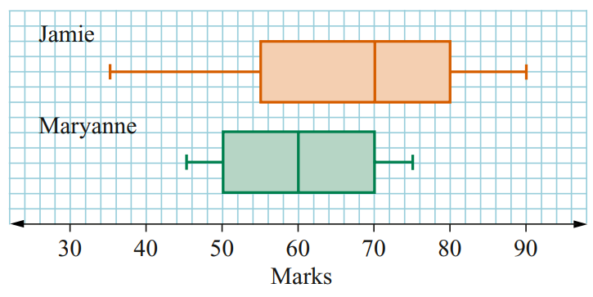

  - Who scored the highest mark?
Jamie
  - Who scored the lowest mark?
Jamie
  - What was the range of marks for each student?
Jamie: 55, Maryanne: 30
  - Who had the greater spread of marks?
Jamie
  - What was the interquartile range for each student?
Jamie: 25, Maryanne: 20
  - Whose marks were the more consistent?
Maryanne, smaller range and IQR
  - Who had more marks over 70?
Jamie had 50% compared to 25% for Maryanne.
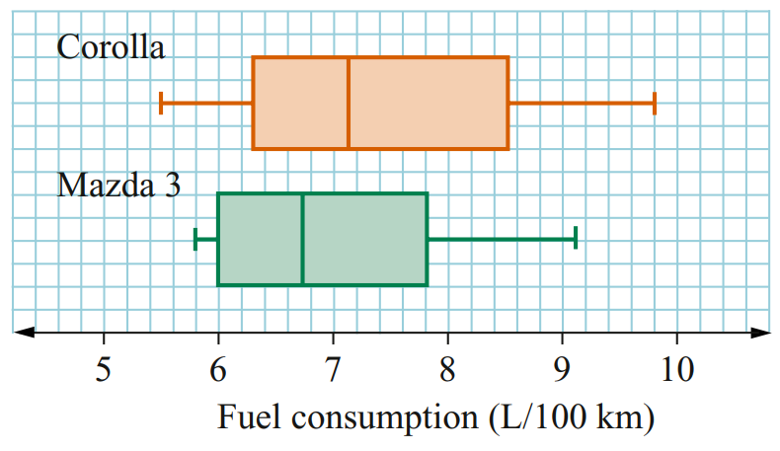
- A new Toyota Corolla and Mazda 3 were each taken for ten test drives over the same routes. These parallel box plots show a summary of the fuel consumption, in L/100 km, of each vehicle

  - Which car recorded the highest fuel consumption?
Corolla
  - Which car recorded the lowest fuel consumption?
Corolla
  - Which car had the greater range of results?
Corolla
  - Which car demonstrated the more consistent fuel consumption over all routes?
Give a reason.
Mazda 3, smaller IQR
  - Which car used less than 7 L/100 km more often?
Corolla was less than 7L/100 km <50% of the time. Mazda 3 was less than 7L/100 km > 50% of the time. So Mazda.

Development
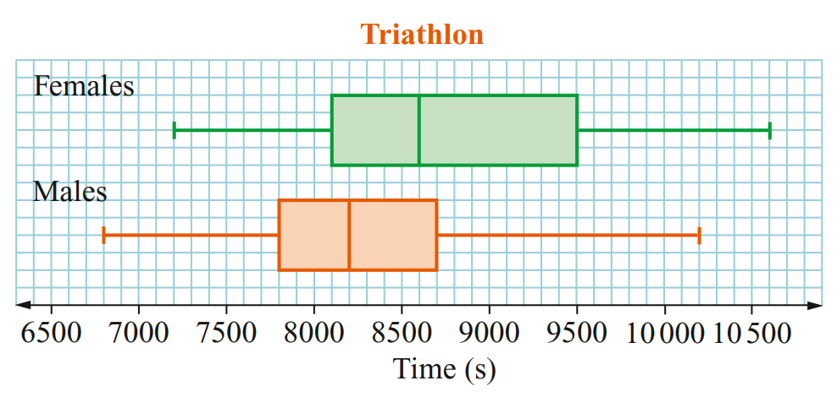
- This parallel box plot shows the times (in seconds) male and female competitors take to complete a triathlon.

  - What was the fastest time for the event?
6800 s
  - What was the difference in time between the slowest male and slowest female competitor?
400 s
  - How long did it take the first half of the male competitors to finish?
8200 s
  - How long did it take the top 75% of the males to finish?
8700 s
  - How long did it take the first 25% of the females to finish?
8100 s
  - Which group had the greatest range of times?
They had the same range
  - Which group had the smallest interquartile range of times?
Males
  - Which group had the fastest overall times?
Males

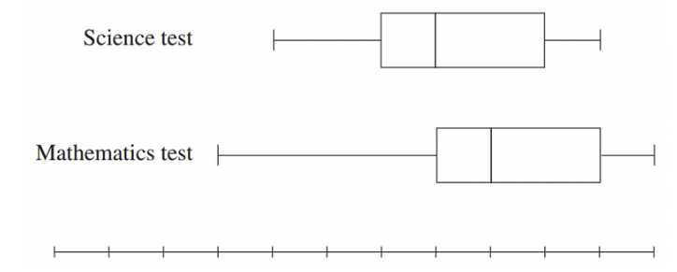
- 2008 HSC Standard 2 Band 4
The marks for a Science test and a Mathematics test are presented in box-and-whisker plots.
Which measure must be the same for both tests?
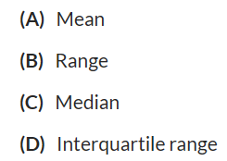

Looking at the box-and-whisker plots, the width of the central box (from the lower quartile to the upper quartile) is the same for both tests.
Therefore, the interquartile range is the same.
D

Mastery
- 2016 HSC Standard 2 Band 4
The box-and-whisker plots show the results of a History test and a Geography test.
In History, 112 students completed the test. The number of students who scored above 30 marks was the same for the History test and the Geography test.
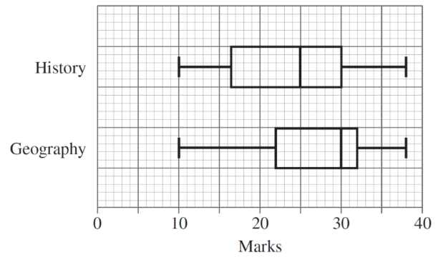
How many students completed the Geography test?
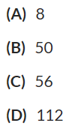

For the History test, $30$ represents the upper quartile ($Q_{3}$). This means $25\%$ of the History students scored above $30$.
$$\begin{matrix}\text{Number of History students above }30 & =0.25×112 \\ & =28\end{matrix}$$We are told this number ($28$) is the same for Geography.
For the Geography test, $30$ represents the median ($Q_{2}$), meaning $50\%$ of the Geography students scored above $30$.
$$\begin{matrix}50\%\text{ of Geography students} & =28 \\ \text{Total Geography students} & =28×2 \\ & =56\end{matrix}$$C
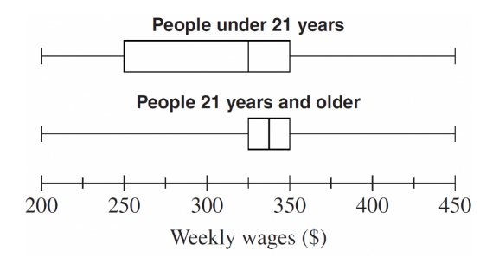
- 2005 HSC Standard 2 Band 6
Two groups of people were surveyed about their weekly wages. The results are shown in the box-and-whisker plots.
Which of the following statements is true for the people surveyed?
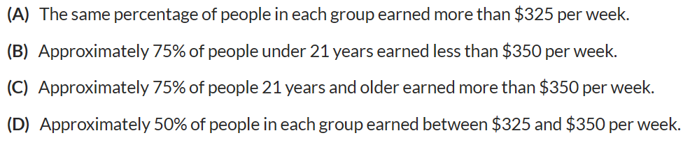

- Option A: For "People under 21 years", $325$ is the median ($50\%$ earned more). For "People 21 years and older", $325$ is the lower quartile ($75\%$ earned more). This is false.
- Option B: For "People under 21 years", $350$ is the upper quartile ($Q_{3}$). This means $75\%$ of this group earned less than $\$350$. This is true.
- Option C: For "People 21 years and older", $350$ is the upper quartile. This means $25\%$ earned more than $\$350$, not $75\%$. This is false.
- Option D: For "People under 21 years", the range $\$325$ to $\$350$ is from $Q_{2}$ to $Q_{3}$ ($25\%$ of the group). This is false.
Therefore, Option B is the only true statement.

Five-Number Summary from Stem-and-Leaf and Dot Plots

- Review
- Determine the median from charts
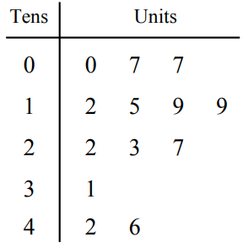 | 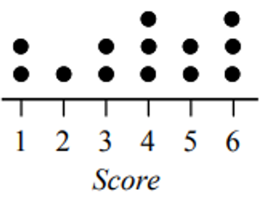

- Example Determine the five-number summary from a stem-and-leaf plot
Construct a box plot from this stem and leaf plot.
Step 1: Find Q2 Step 2: Find Q1 and Q3 Step 3: Draw box plot
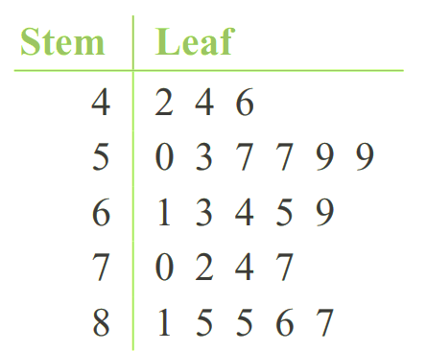
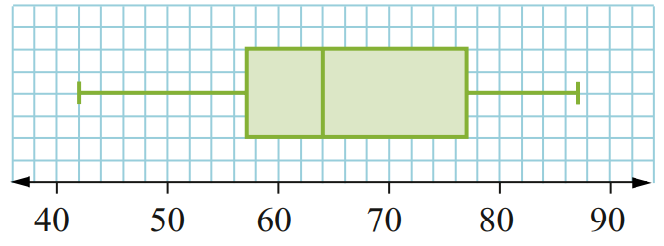

- Guided Practice
Draw a box plot from the stem-and-leaf plots.
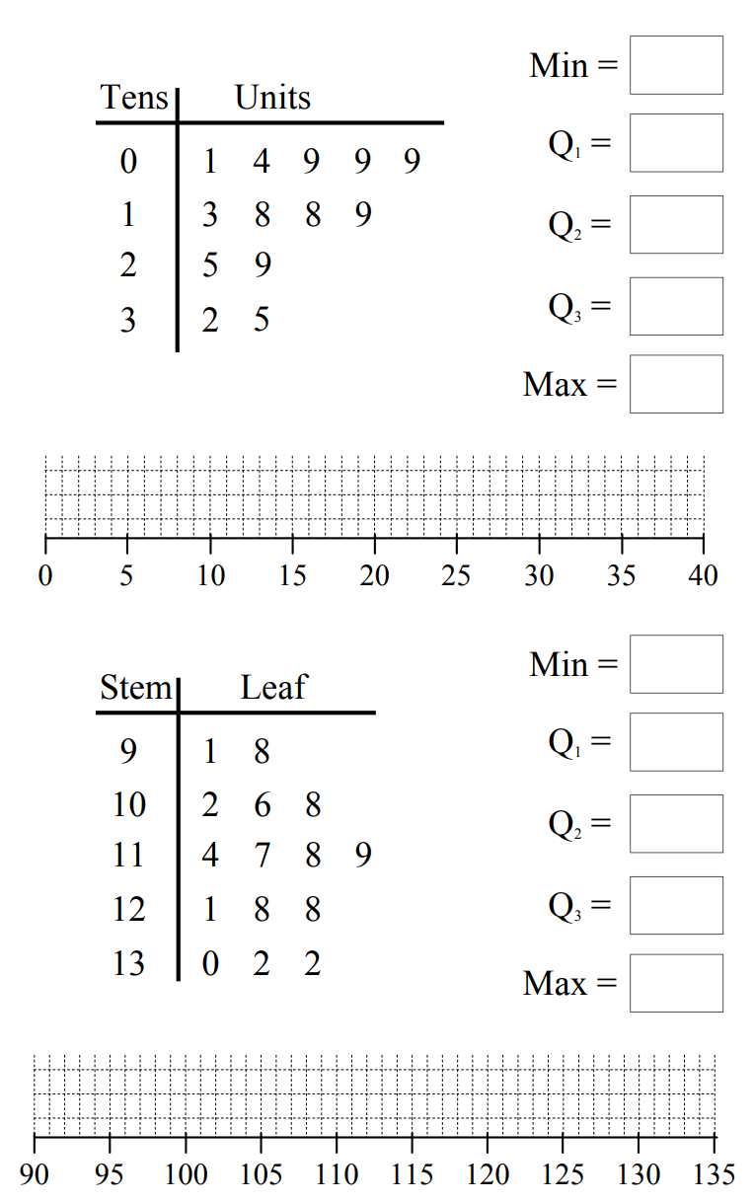  FNS: 1, 9, 18, 27, 35 | FNS: 91, 106, 118, 128, 132

- Example Determine the five-number summary from a stem-and-leaf plot
Construct a box plot from this dot plot.
Step 1: Find Q2 Step 2: Find Q1 and Q3 Step 3: Draw box plot
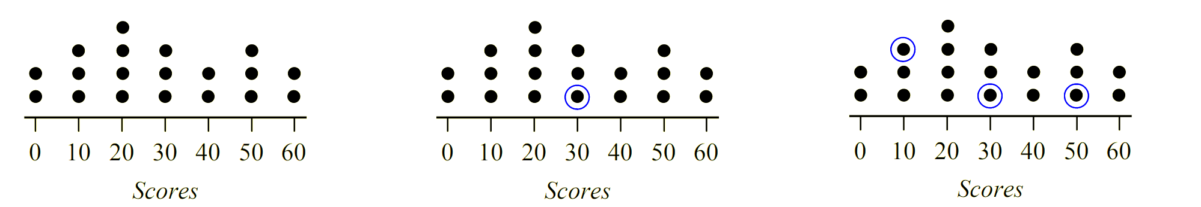
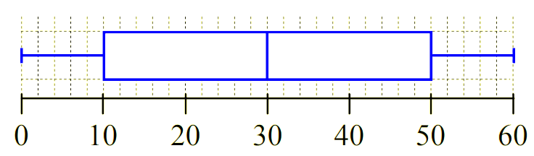

- Guided Practice
Draw a box plot from the dot plot.
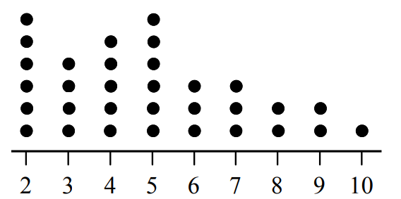  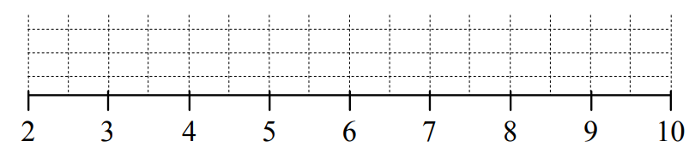  FNS: 2, 3, 5, 6.5, 10 | 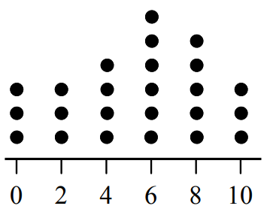  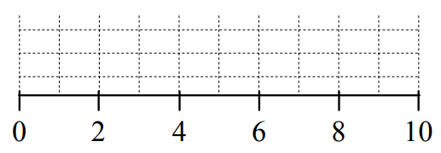  FNS: 0, 3, 6, 8. 10
  Min: | $Q_{1}:$ | $Q_{2}:$ | $Q_{3}:$ | Max:
  Min: | $Q_{1}:$ | $Q_{2}:$ | $Q_{3}:$ | Max:

Foundation
- Determine the five-number summary from these stem-and-leaf plots.
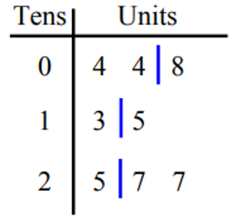  4, 6, 14, 26, 27 | 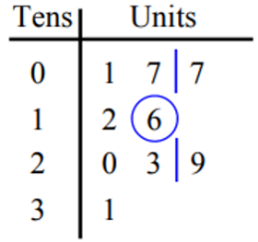  1, 7, 16, 26, 31 | 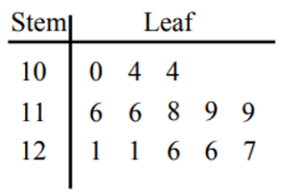  100, 110, 119, 123.5, 127
  Min: | $Q_{1}:$ | $Q_{2}:$ | $Q_{3}:$ | Max:
  Min: | $Q_{1}:$ | $Q_{2}:$ | $Q_{3}:$ | Max:
  Min: | $Q_{1}:$ | $Q_{2}:$ | $Q_{3}:$ | Max:
80, 93, 105, 107, 115 | 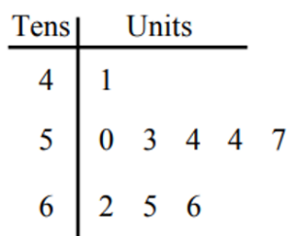  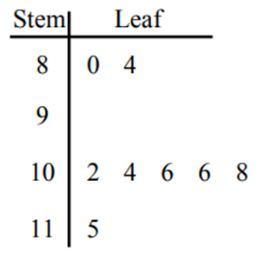  41, 51.5, 54, 63.5, 66 | 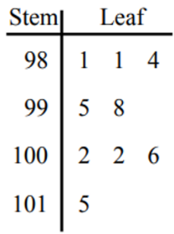  981, 982.5, 998, 1004, 1015
  Min: | $Q_{1}:$ | $Q_{2}:$ | $Q_{3}:$ | Max:
  Min: | $Q_{1}:$ | $Q_{2}:$ | $Q_{3}:$ | Max:
  Min: | $Q_{1}:$ | $Q_{2}:$ | $Q_{3}:$ | Max:

- Determine the five-number summary from these dot plots.
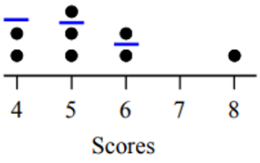  4, 4.5, 5, 6, 8 | 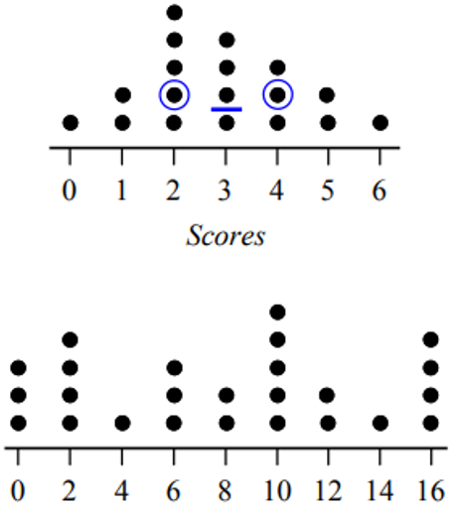  0, 2, 3, 4, 6 | 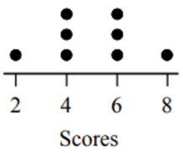  2, 4, 5, 6, 8
  Min: | $Q_{1}:$ | $Q_{2}:$ | $Q_{3}:$ | Max:
  Min: | $Q_{1}:$ | $Q_{2}:$ | $Q_{3}:$ | Max:
  Min: | $Q_{1}:$ | $Q_{2}:$ | $Q_{3}:$ | Max:
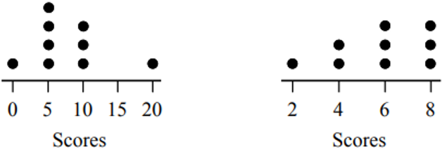  0, 5, 5, 10, 20 | 2, 4, 6, 8, 8 | 0, 2, 8, 12, 16
  Min: | $Q_{1}:$ | $Q_{2}:$ | $Q_{3}:$ | Max:
  Min: | $Q_{1}:$ | $Q_{2}:$ | $Q_{3}:$ | Max:
  Min: | $Q_{1}:$ | $Q_{2}:$ | $Q_{3}:$ | Max:

Development
- Determine the five-number summary and draw a box plot of the data.
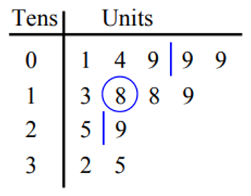  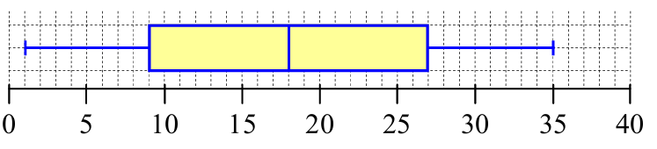  FNS: 1, 9, 18, 27, 35 | 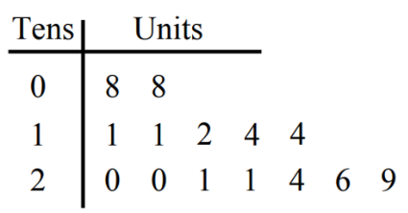  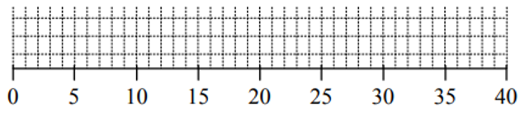  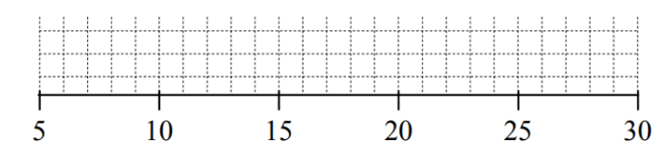  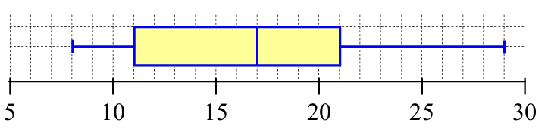  FNS: 8, 11, 17, 21, 29
  Min: | $Q_{1}:$ | $Q_{2}:$ | $Q_{3}:$ | Max:
  Min: | $Q_{1}:$ | $Q_{2}:$ | $Q_{3}:$ | Max:

- Determine the five-number summary and draw a box plot of the data.
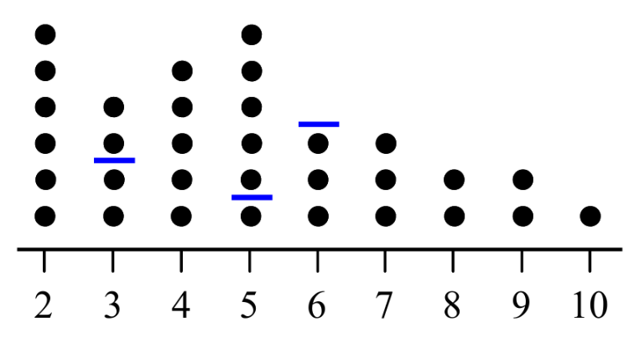  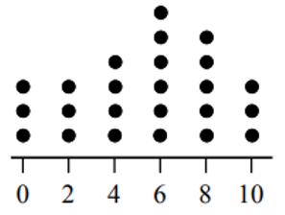  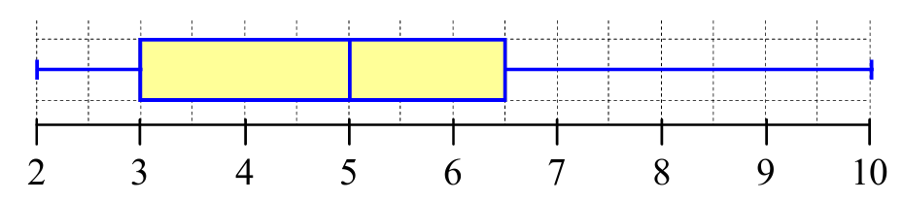  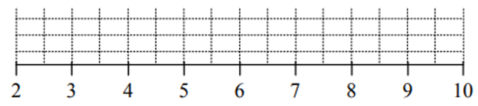  FNS: 2, 3, 5, 6.5, 10 | 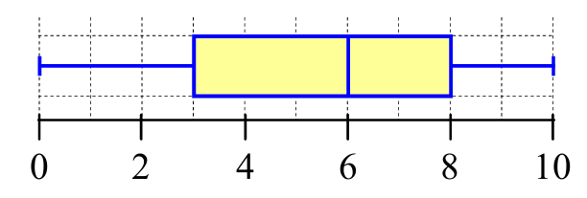  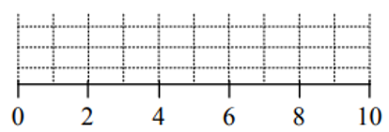  FNS: 0, 3, 6, 8, 10
  Min: | $Q_{1}:$ | $Q_{2}:$ | $Q_{3}:$ | Max:
  Min: | $Q_{1}:$ | $Q_{2}:$ | $Q_{3}:$ | Max:

Five-Number Summary from Cumulative Histograms

- Review
- Identify median from cumulative frequency histograms
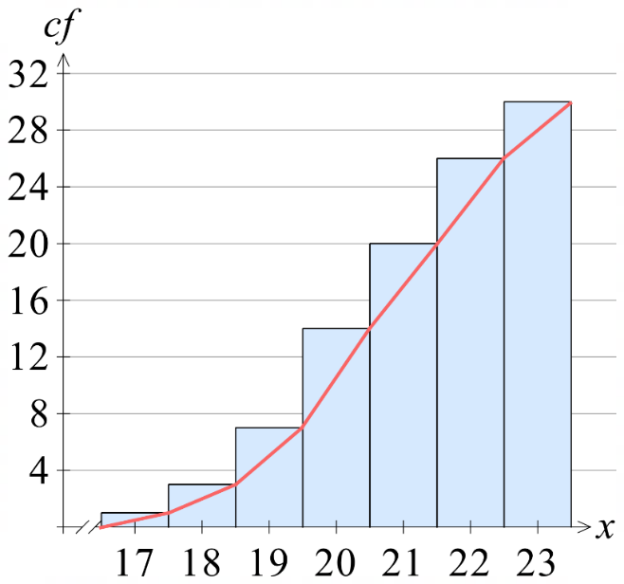 | 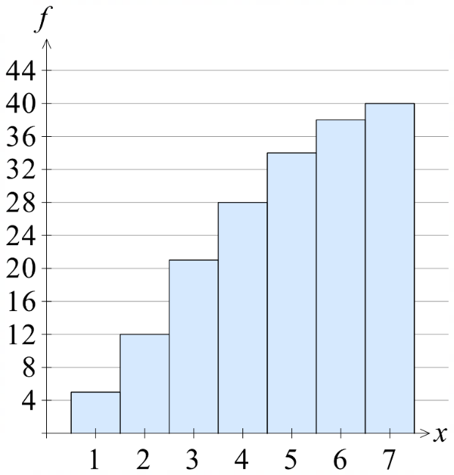  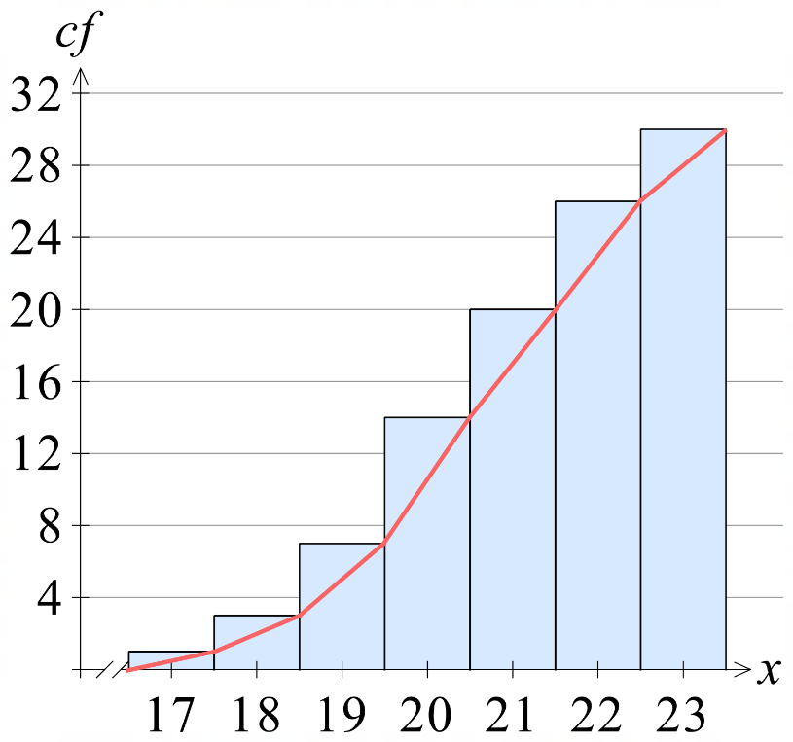

- Five Number Summary from Cumulative Histogram
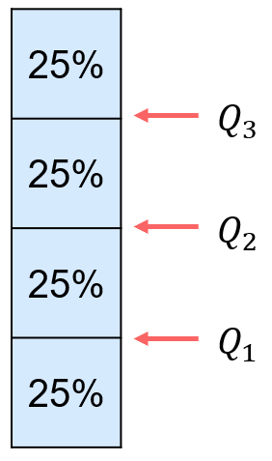
- Identify the total number of scores. This is the height of the last column.
- Find $Q_{1}$ position: $0.25×total$
- Find $Q_{2}$ position: $0.5×total$
- Find $Q_{3}$ position: $0.75×total$
- Draw horizontal lines from the vertical axis to the ogive,
then estimate the $x$ values.

- Example Estimate quartiles from a cumulative histogram
1. Total scores: 40 5.
2. $Q_{1}$ position $=0.25×40=10$
3. $Q_{2}$ position $=0.5×40=20$
4. $Q_{3}$ position $=0.75×40=30$

Min | $$Q_{1}$$ | $$Q_{2}$$ | $$Q_{3}$$ | Max
1 | 2 | 3 | 5 | 7

$$IQR=5-2=3$$

- Guided Practice
Determine the five-number summary and IQR from these cumulative histograms.
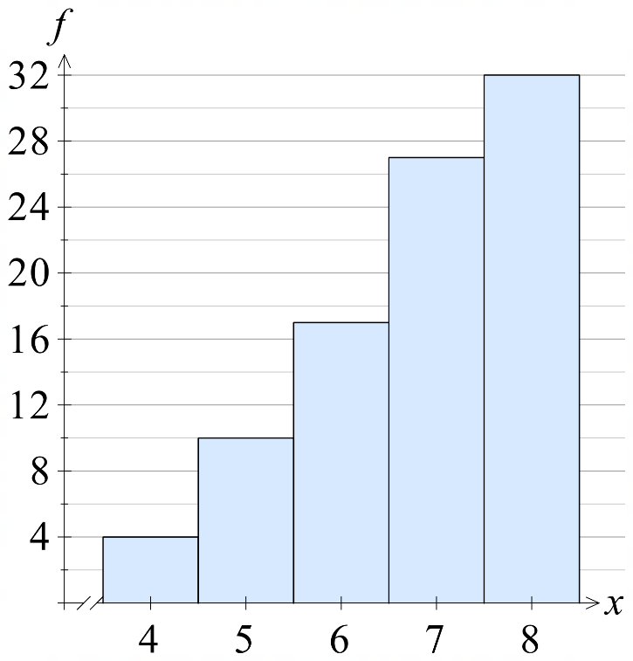

FNS: 4, 5, 6, 7, 8
IQR = 2

FNS: 17, 20, 21, 22, 23
IQR = 2
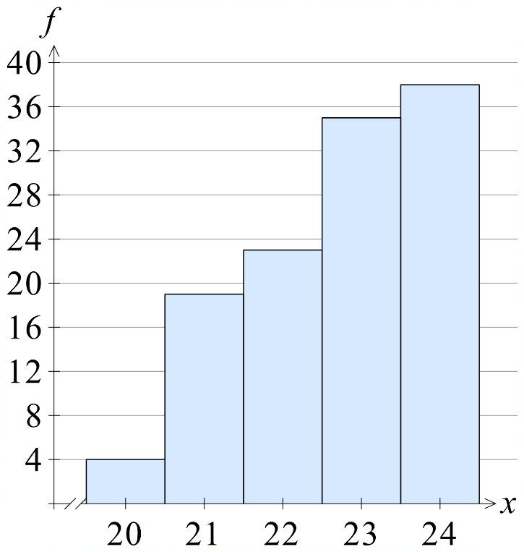

FNS: 20, 21, 21.5, 23, 24
IQR = 2

Foundation
- Estimate the five-number summary from these cumulative histograms and give the IQR.
45.5, 65.5, 75.5, 85.5, 95.5  IQR: 20 | 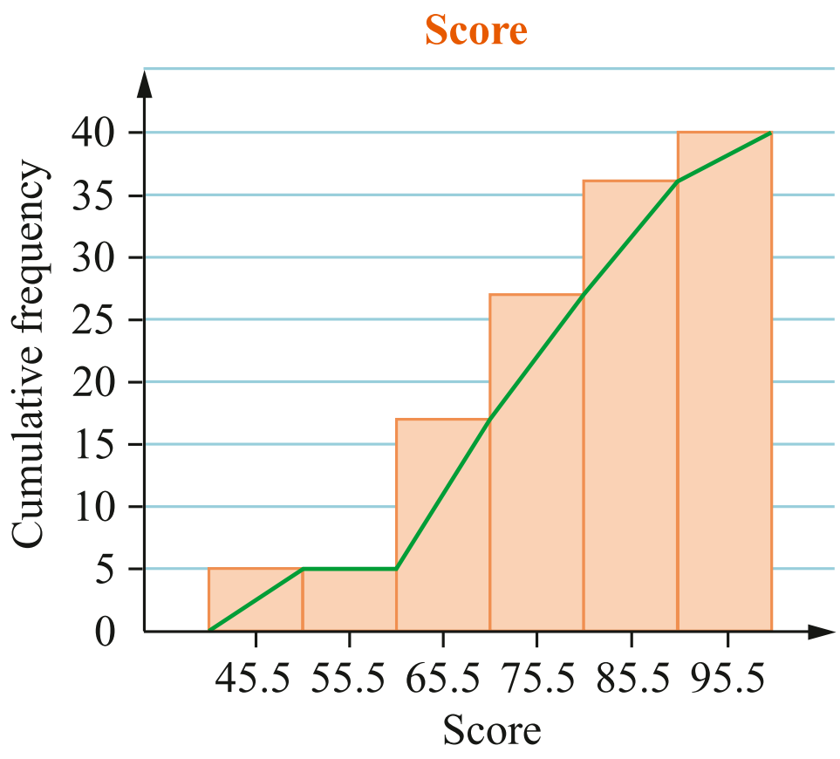  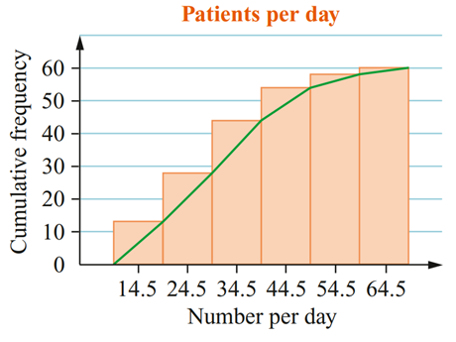  14.5, 24.5, 34.5, 44.5, 64.5  IQR: 20
  Min: | $Q_{1}:$ | $Q_{2}:$ | $Q_{3}:$ | Max:
  Min: | $Q_{1}:$ | $Q_{2}:$ | $Q_{3}:$ | Max:
61, 64, 67, 70, 73  IQR: 6 | 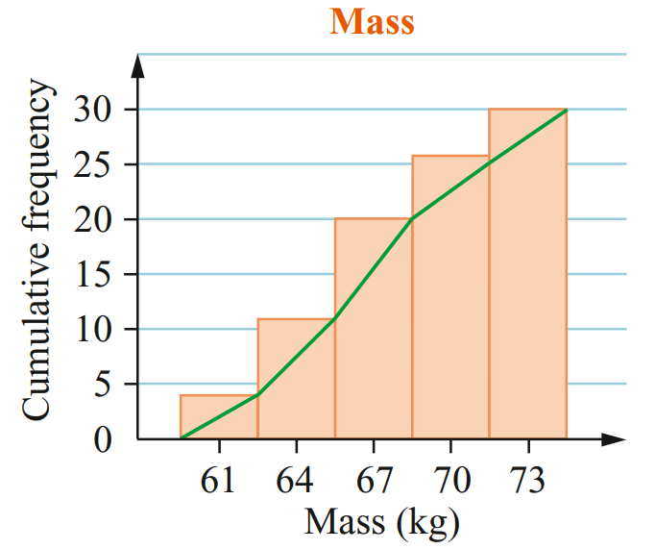  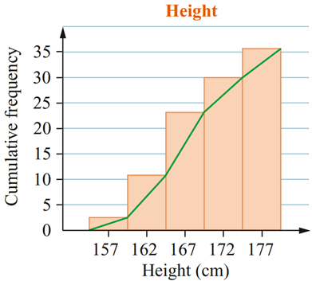  157, 164, 167, 172, 177  IQR: 8
  Min: | $Q_{1}:$ | $Q_{2}:$ | $Q_{3}:$ | Max:
  Min: | $Q_{1}:$ | $Q_{2}:$ | $Q_{3}:$ | Max:

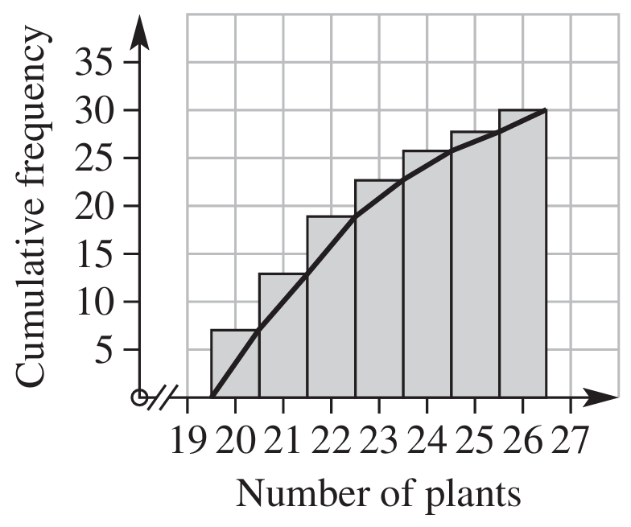
- Determine IQR from this graph.

Q1: 20.5, Q3: 23.5
IQR = 3

Development
- Determine the IQR for these cumulative histograms.
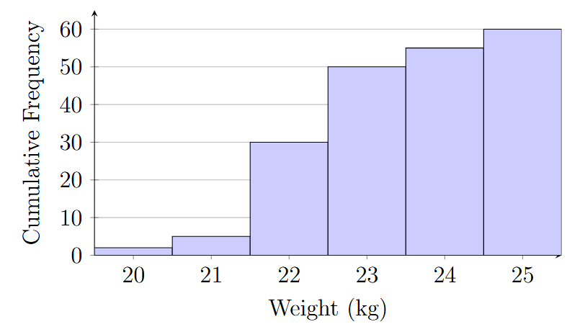  23 – 22 = 1 | 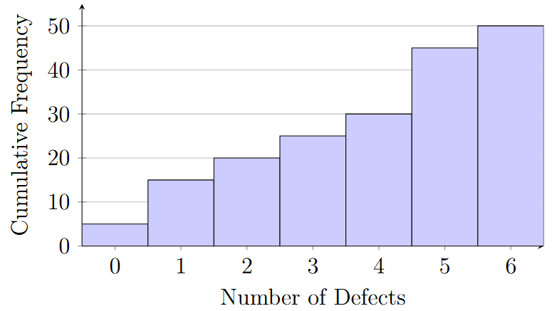  5 – 1 =4

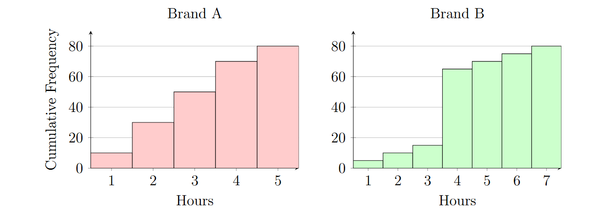
- Two cumulative frequency histograms display the battery life (in hours) of two different phone brands. Each brand tested 80 batteries.

Calculate the IQR for both. Which brand has a more consistent middle 50% of battery lives? Justify your answer using your calculations.

Brand A has an IQR of 2
Brand B has an IQR of 0, so Brand B is more consistent.
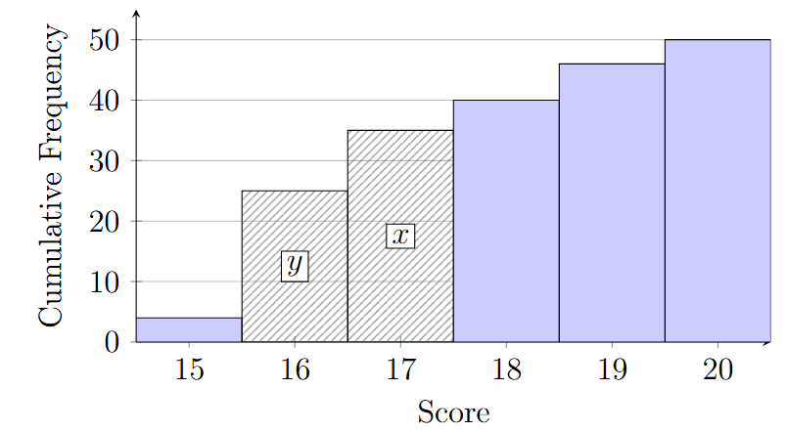
- A cumulative frequency histogram for a dataset of 50 scores is partially damaged, obscuring the heights of the bars for scores 16 and 17. The remaining bars are intact. It is known that the IQR is 2. What is the minimum height of the bar, $y$?

We know Q3 = 18. Since the IQR is 2, Q1 = 16
So, the 12.5th score must be 16;
For the average of two integers to be exactly 16, the pairs could theoretically be (16, 16), (15, 17), or (14, 18).
since we know the height of 15 is 4, there is no way for the 12th score to be 16 and the 13th score to be 17.
Therefore, the 13th score must be 16.
So, the minimum height of the 16 column is 13.

Skewness of Box Plots

- Skewness and Box Plots
Negatively Skewed | Symmetrical |  | Positively Skewed
Tail to the left | Symmetric data |  | 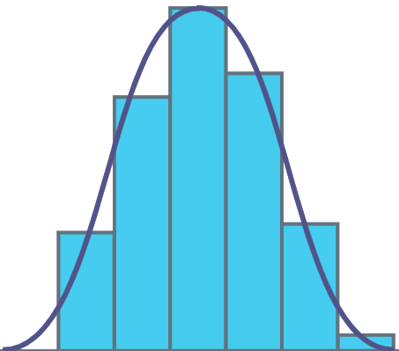  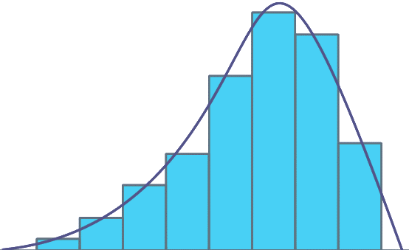  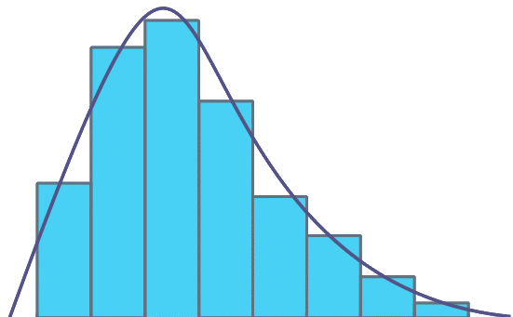  Tail to the right
The whiskers of a box plot tell us about the shape of the distribution.
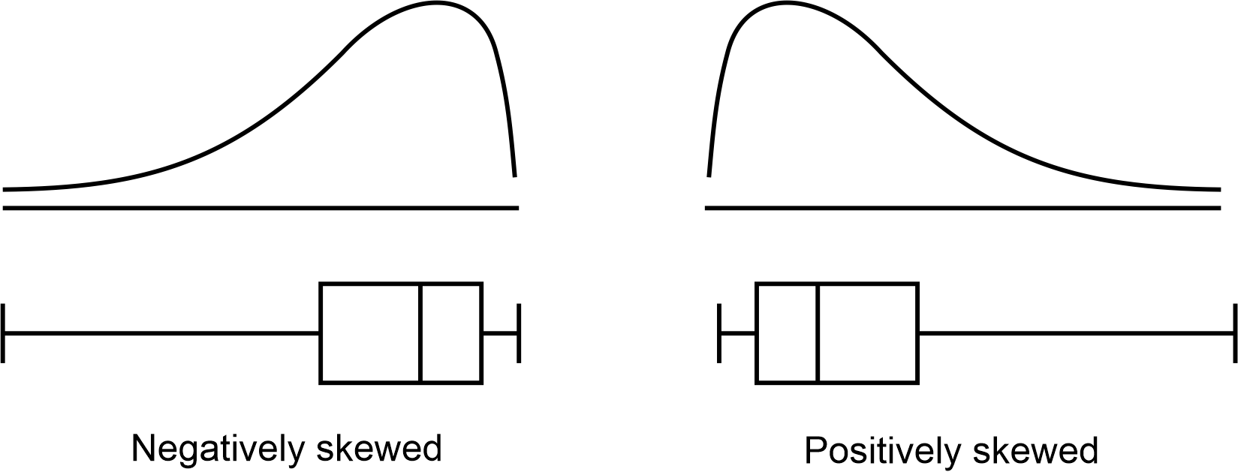

- Identify Skewness of box plot
Identify these box plots as symmetrical or positively or negatively skewed
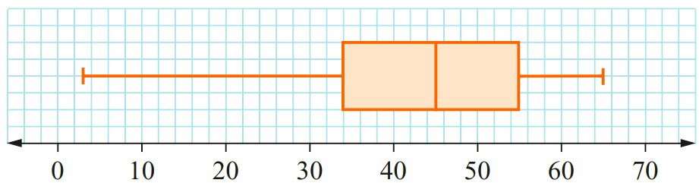 | 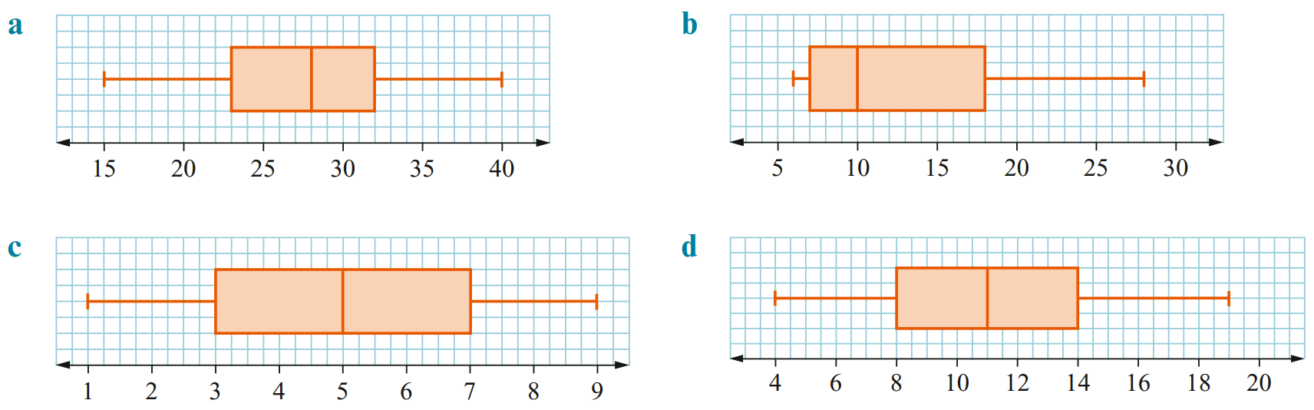
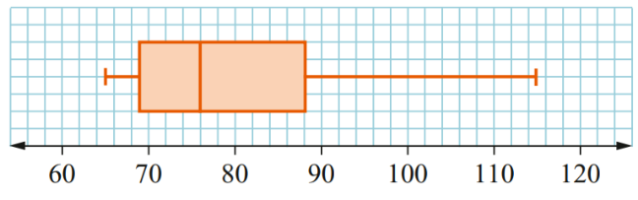

Foundation
- Describe the shape of the data distribution for each box plot.
symmetrical | 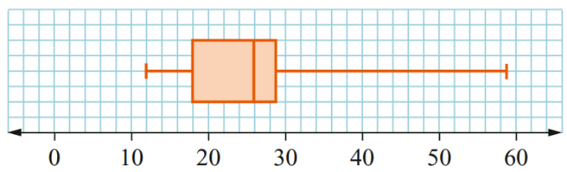  Positively skewed
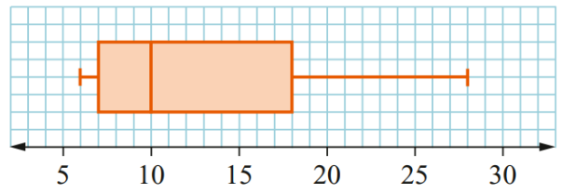  Positively skewed | 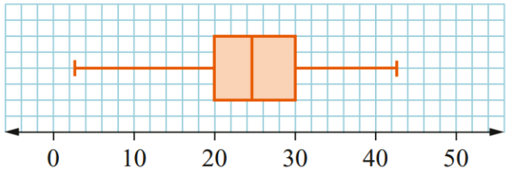  Negatively skewed (slightly)
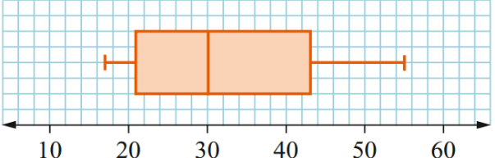  Positively skewed | 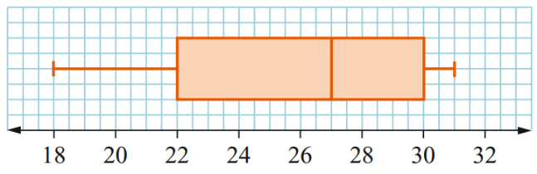  Negatively skewed

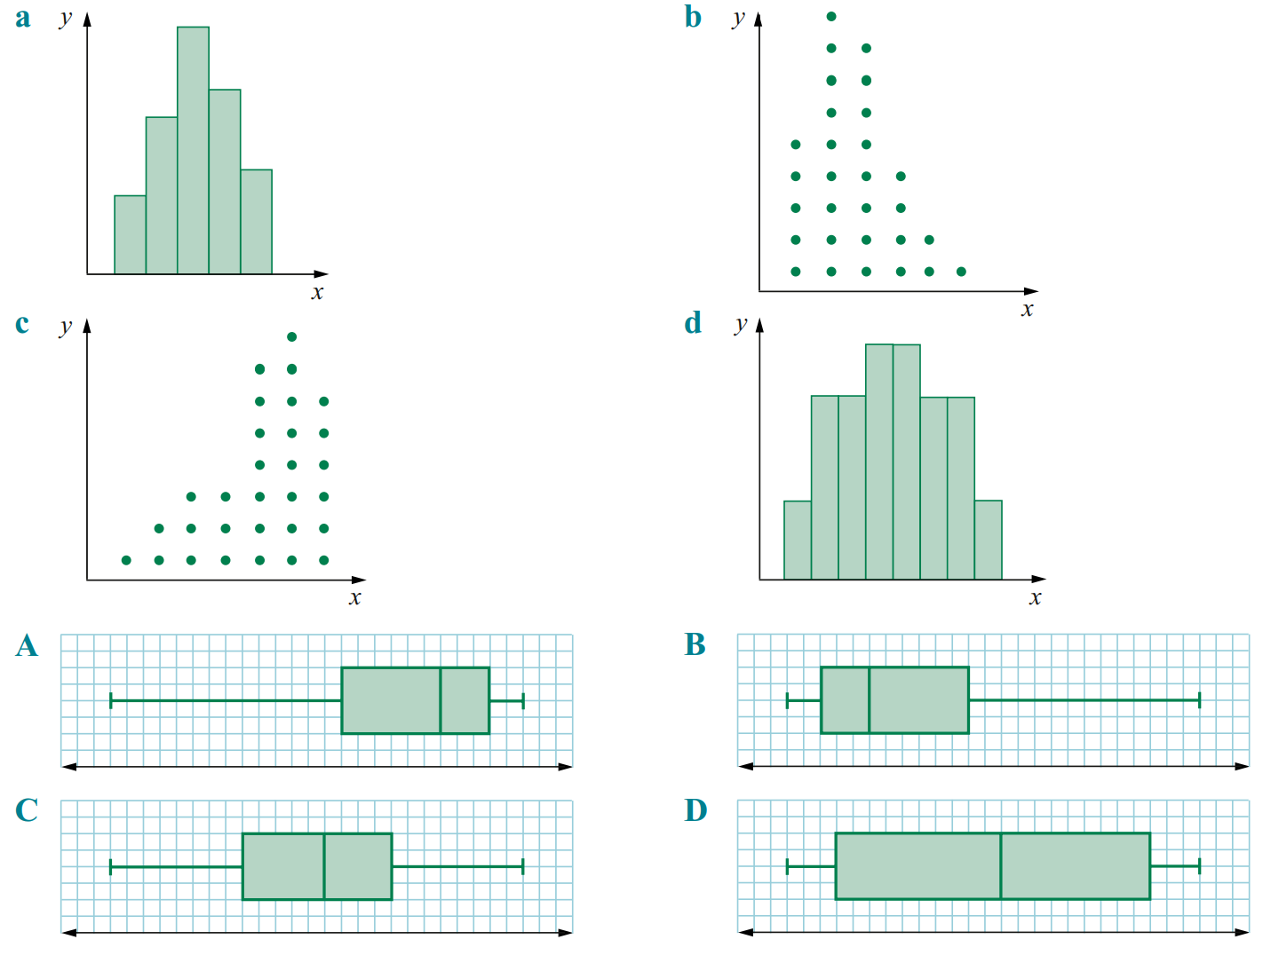
- Match each histogram or dot plot with its corresponding box plot.

a – C, b – B,
c – A, d – D
- First find the five-number summary, then sketch the box plot and decide its skewness
  - 16, 21, 35, 41, 47, 58, 62, 72.

Min: | $Q_{1}:$ | $Q_{2}:$ | $Q_{3}:$ | Max:

16, 28, 44, 60, 72
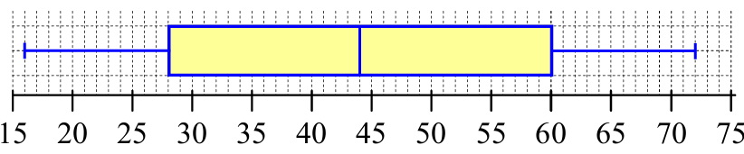
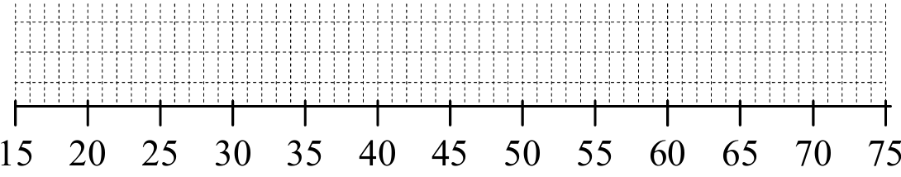

Positive skew | Negative skew | Symmetric
Symmetric

  - 62, 64, 68, 74, 86, 94, 107, 111, 126, 145.

Min: | $Q_{1}:$ | $Q_{2}:$ | $Q_{3}:$ | Max:

62, 68, 90, 111, 145
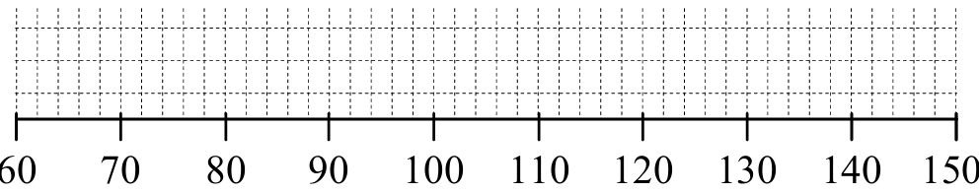
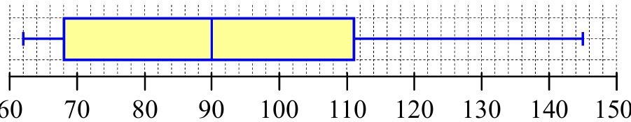

Positive skew | Negative skew | Symmetric
Positive skew
  - 4, 17, 25, 27, 38, 44, 55, 58, 76, 76, 84, 86, 88

Min: | $Q_{1}:$ | $Q_{2}:$ | $Q_{3}:$ | Max:

4, 26, 55, 80, 88
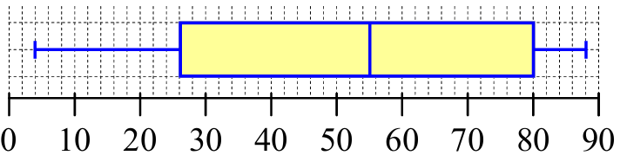
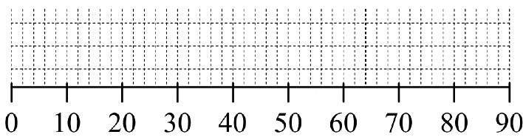

Positive skew | Negative skew | Symmetric
Negative skew

Development
- The parallel box-and-whisker plot shows the amount of data uploaded and downloaded by Anthony each day for the past month.
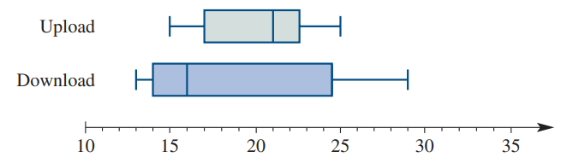

  - Does data uploaded or data downloaded have a larger range?
downloaded
  - Does data uploaded or downloaded have a larger interquartile range?
downloaded
  - What is the median amount of data downloaded and uploaded?
Downloaded: 16, uploaded: 21
  - Describe the shape of the distribution for data uploaded and data downloaded.
Uploaded: negatively skewed
Downloaded: positively skewed
- Two bookstores recorded the selling price of all their books.
The results are presented in the parallel box plots:
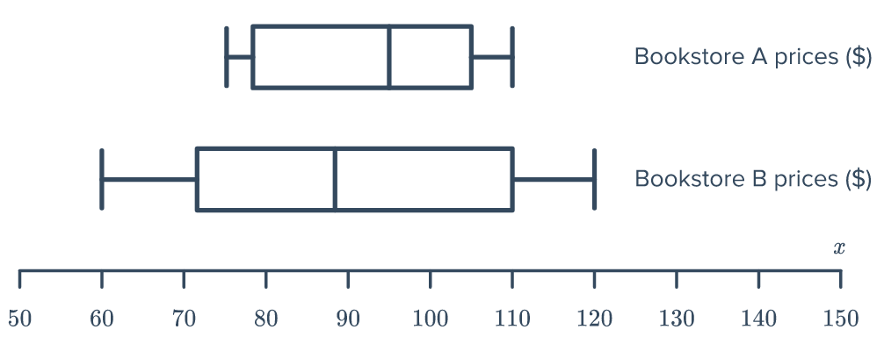

  - Which bookstore had the more consistent prices?
A, smaller range and IQR
  - Comparing the most expensive books in each store, how much more expensive is the one in store B?
$10 more expensive
  - True or False: 25% of the books in Bookstore B are at least as expensive than the most expensive book in Bookstore A.
True
  - True or False: 25% of the books in Bookstore B are cheaper than the cheapest book in Bookstore A.
True
- A cinema is showing three films, labelled A, B, and C.
The ages of people watching the films are illustrated in the three parallel box plots.
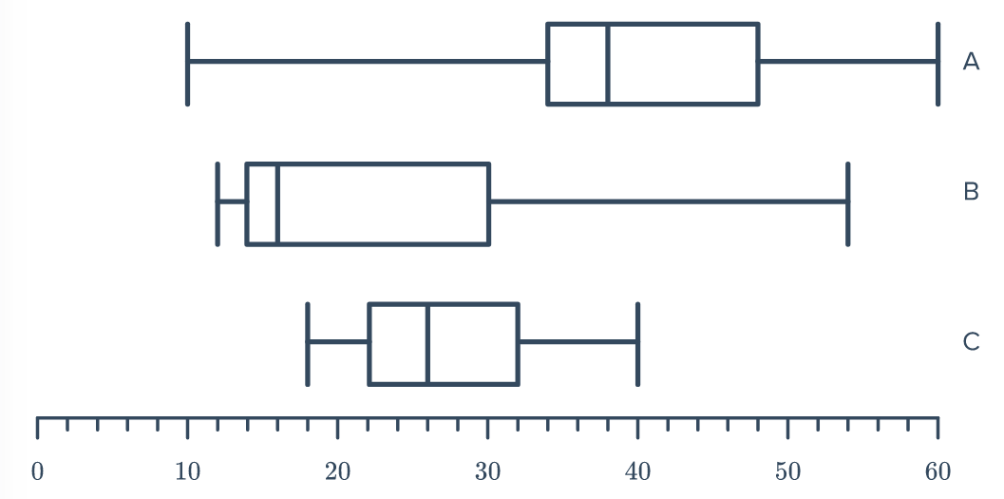

  - One of the films is very violent and is restricted for viewers under 18.
Which film do you think it is? Explain your answer.
Movie C, since no one under 18 has watched it
  - Which film would you recommend for a group of 15-year-olds to watch?
Explain your answer, making reference to skewness and clustering.

Movie B. The median age is 15 and the ages are positively skewed
  - Which film would you recommend to two 40 year olds on a date night?

Movie A, the median age is 38.

- A cyclist measures her heartrate in beats per minute (bpm) before and after a ride.
  - Which box plot do you think is before her ride and which is after?
Explain with reference to clustering.
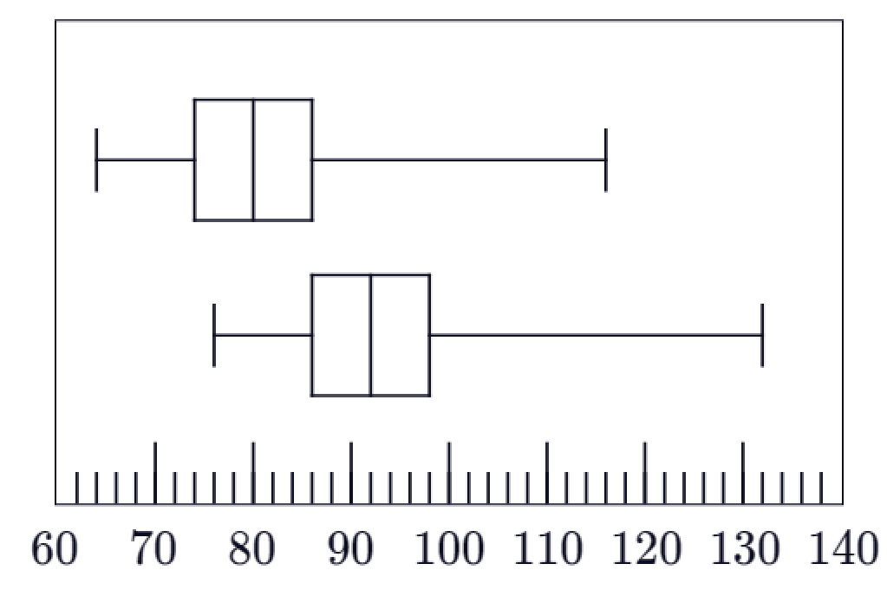

The top box plot represents her heart rate before the ride.
The bottom box plot represents her heart rate after the ride.
In the bottom plot, this main cluster has shifted to higher values (between 86 and 98 bpm), which is what we would expect after exercise.
  - Compare her IQR before and after a ride. Does her heartrate remain consistent?

Before the ride, IQR is 12
After the ride, IQR is also 12
Yes, her heart rate remains consistent in terms of its variability.
Because the IQR is 12 in both scenarios, the spread of the middle 50% of her heart rate readings is identical before and after the ride, even though her overall heart rate increased.

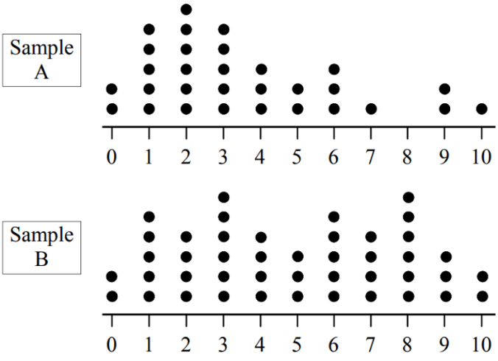
- Draw box plots to compare these two datasets.
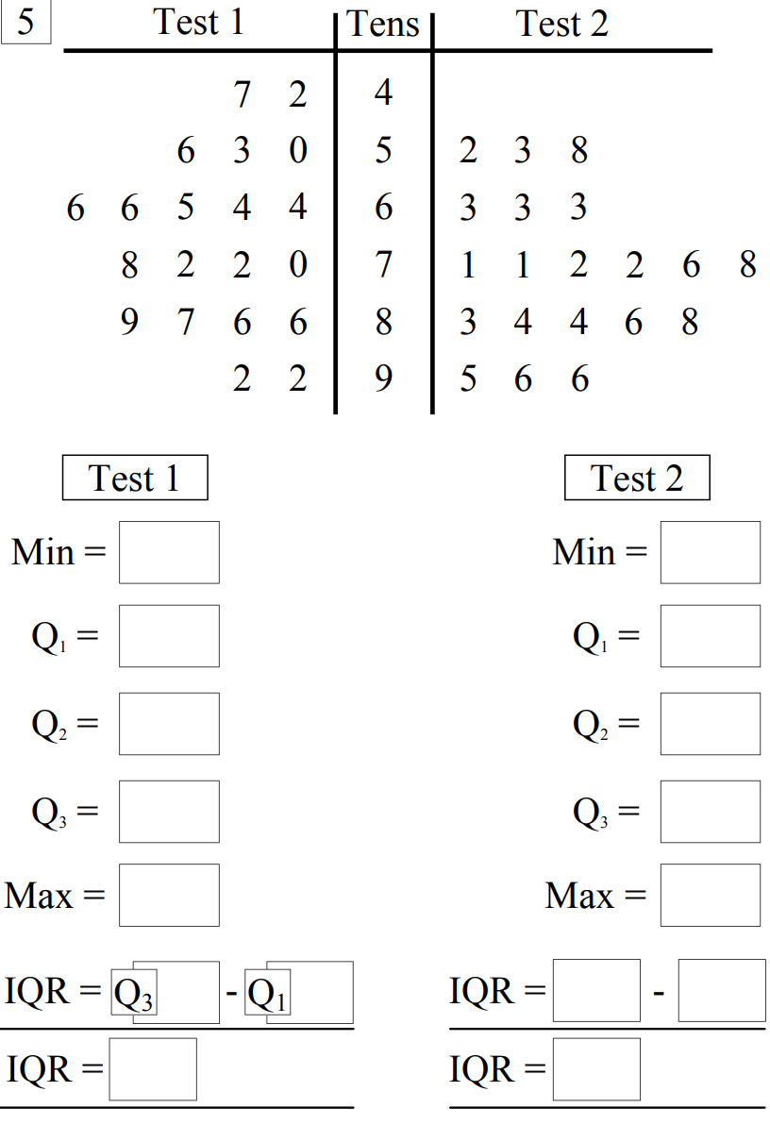  Test 1: 42, 60, 68, 86, 92.  Test 2: 52, 63, 74, 85, 96.  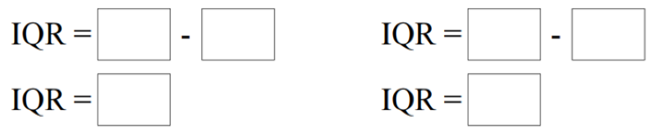  IQR = 26  IQR = 22  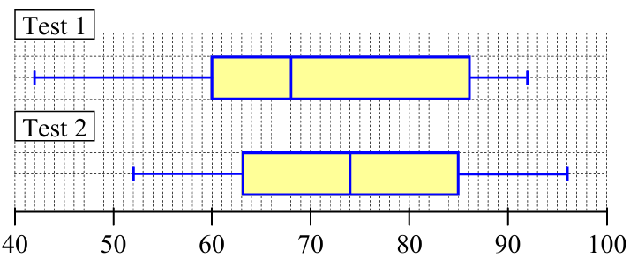  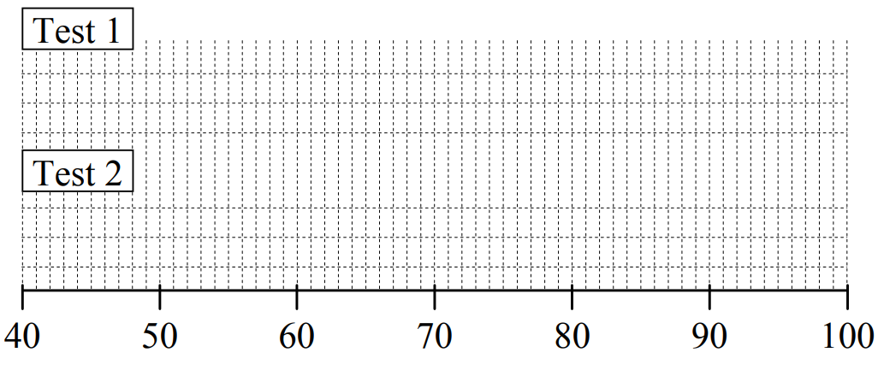  Write a few sentences comparing the measures of centre, spread, and skewness.  Test 1 is negatively skewed, has a larger IQR and a larger range. Test 2 is symmetric has a lower IQR and range.  Test 2 has higher values | 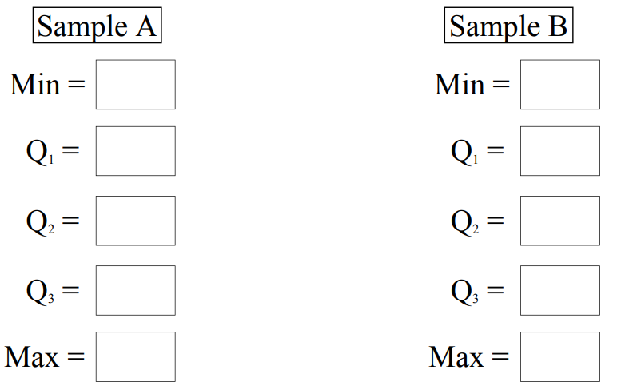  A: 0, 2, 3, 5, 10  B: 0, 2.5, 5, 7.5, 10  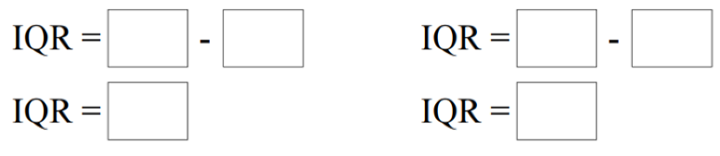  IQR = 3  IQR = 5  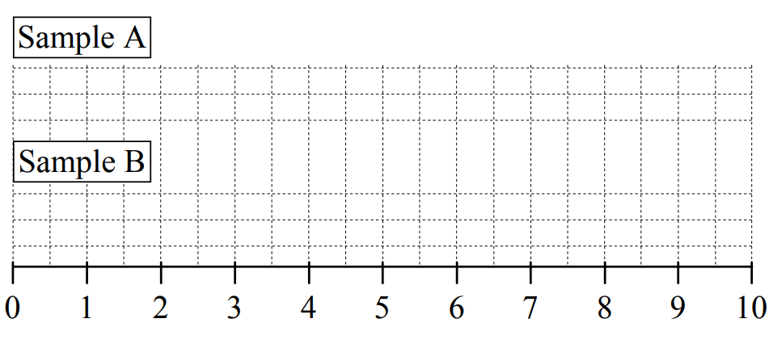  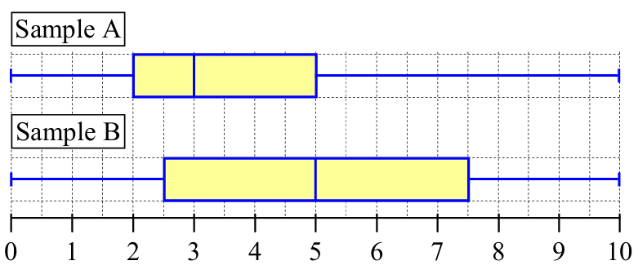  Write a few sentences comparing the measures of centre, spread, and skewness.  Sample A is positively skewed with a smaller IQR.  Sample B is symmetric with a larger IQR.  Both samples have the same range, Sample B has a higher median.

Mastery
- 2011 HSC Standard 2 Band 5
A set of data is displayed in this box-and-whisker plot.
Which of the following best describes this set of data?
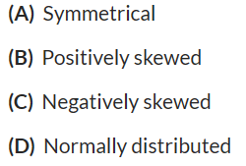
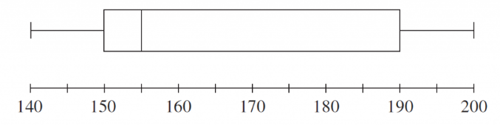

Tail to the right. B

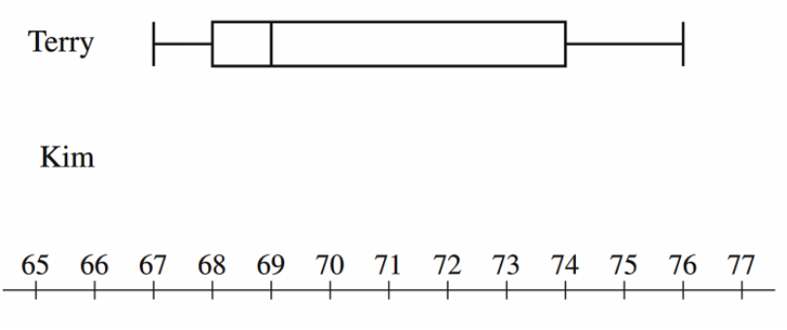
- 2014 HSC Standard 2 Band 5
Terry and Kim each sat twenty class tests. Terry’s results on the tests are displayed in the box-and-whisker plot shown.

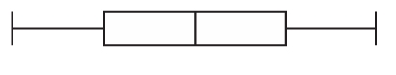

  - Kim’s 5-number summary for the tests is 67, 69, 71, 73, 75.
Draw a box-and-whisker plot to display Kim’s results below that of Terry’s results.
  - What percentage of Terry’s results were below 69?
From Terry's box plot, $69$ corresponds to the median.
Therefore, $50\%$ of Terry's results were below 69.
  - Terry claims that his results were better than Kim’s. Is he correct?
Justify your answer by referring to the summary statistics and the skewness of the distributions.
Terry's claim is incorrect. Kim's results are generally better because:
- Median: Kim has a higher median score of 71 compared to Terry's median of 69.
- Quartiles/Spread: $75\%$ of Kim's scores are 69 or above ($Q_{1}=69$), whereas only $50\%$ of Terry's scores are 69 or above.
- Range and IQR: Kim's data is more consistent, with a smaller Interquartile Range ($73-69=4$) compared to Terry's IQR ($74-68=6$), and a smaller overall range ($75-67=8$) compared to Terry's ($76-67=9$).
- Skewness: Kim's distribution is symmetrical, whereas Terry's is positively skewed, meaning the majority of his scores cluster at the lower end.

- 2012 HSC Standard 2 Band 5
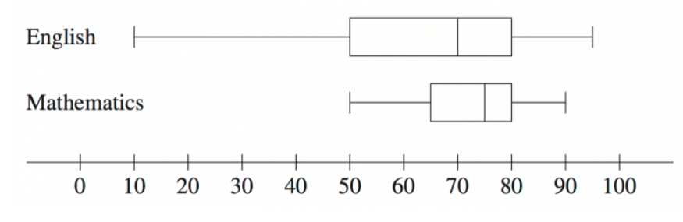
The test results in English and Mathematics for a class were recorded and displayed in the box-and-whisker plots.

  - What is the interquartile range for English?
30
  - Compare and contrast the two data sets by referring to the skewness of the distributions and the measures of location and spread.
Skewness: Both data sets are negatively skewed, as the left whisker is longer and the median is closer to the upper quartile.
Location: Mathematics has a higher median ($75$) compared to English ($70$). The minimum score is also much higher in Mathematics ($50$) than English ($10$).
Spread: English has a much larger range ($95-10=85$) compared to Mathematics ($90-50=40$). English also has a larger interquartile range ($30$) compared to Mathematics ($80-65=15$), meaning the middle 50% of scores in English are more spread out.

- 2010 HSC Standard 2 Band 5
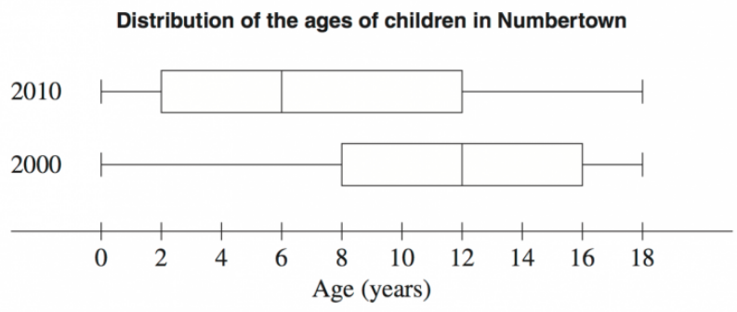
The graphs show the distribution of the ages of children in Numbertown in 2000 and 2010.

  - In 2000 there were 1750 children aged 0–18 years.
How many children were aged 12–18 years in 2000?
$$50\%×1750=875$$
  - The number of children aged 12–18 years is the same in both 2000 and 2010.
How many children aged 0–18 years are there in 2010?
875 represents 25% of 2010’s data, so 100% is 3500
  - Identify TWO changes in the distribution of ages between 2000 and 2010.
In your answer, refer to measures of location or spread or the shape of the distributions.
There is a greater proportion of younger children in 2010 than in 2000.
Specifically, the median age has decreased from 12 years in 2000 to 6 years in 2010.
2. In 2000, the distribution is negatively skewed (longer tail to the left), whereas in 2010 it is positively skewed (longer tail to the right).

  - What would be ONE possible implication for government planning, because of this change in the distribution of ages?
Because there is a much larger number and proportion of young children (e.g., ages 0-6) in 2010 compared to 2000, a possible implication is that the government will need to plan and build more primary schools or early childhood daycare centres to accommodate them.

- 2022 HSC Standard 2 Band 6
The cumulative frequency graph shows the distribution of the number of movie downloads made by 100 people in one month.
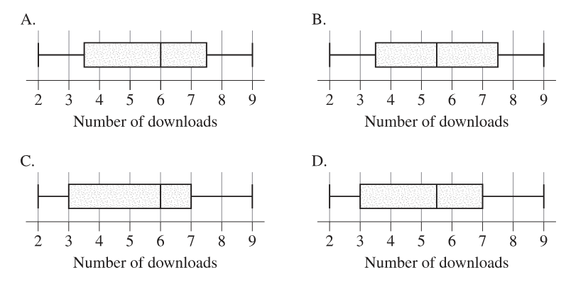
Which box-plot best represents the same data as displayed in the cumulative frequency graph?
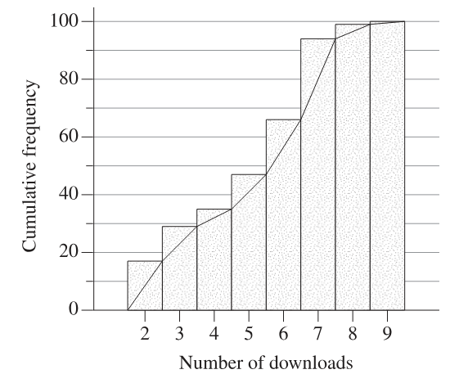

Using the cumulative frequency graph to find the five-number summary for 100 people:
Minimum: The lowest score is $2$.
Lower Quartile ($Q_{1}$): The 25th value. Reading across from 25 on the cumulative frequency axis, we hit the graph at a score of $3$.
Median: The 50th value. Reading across from 50, we hit the graph at a score of $6$.
Upper Quartile ($Q_{3}$): The 75th value. Reading across from 75, we hit the graph at a score of $7$.
Maximum: The highest score is $9$.
The box-plot must have its minimum at $2$, $Q_{1}$ at $3$, median at $6$, $Q_{3}$ at $7$, and maximum at $9$.
Graph C matches these values.

Formal Definition of an Outlier

- Formal Definition of an Outlier

Data values more than 1.5 times the IQR below Q₁ and above Q₃ is defined as an outlier.

- Example Identify outliers using the formal definition
Identify any outliers in this sample of scores. Justify your answer.
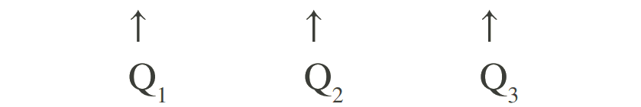
30, 50, 50, 52, 55, 55, 57, 57, 58, 60, 60

$IQR=Q_{3}-Q_{1}$
$=58-50=8$
Lower limit $=Q_{1}-1.5×IQR$  $=50-1.5×8$  $=38$ | Upper limit $=Q_{3}+1.5×IQR$  $=58+1.5×8$  $=70$
30 is outside the range of 38 to 70, so it is an outlier.

- Guided Practice
Determine the outlier in these scores.
- 3, 24, 25, 26, 26, 26, 28, 29, 30, 32

IQR =
4
Lower fence $=Q_{1}-1.5×IQR$  $=$ | Upper fence $=Q_{3}+1.5×IQR$  $=$
3 is an outlier, outside the range of 19 – 35.

- 17, 31, 32, 32, 34, 35, 35, 36, 38, 41, 44, 45

IQR =
7.5
Lower fence $=Q_{1}-1.5×IQR$  $=$ | Upper fence $=Q_{3}+1.5×IQR$  $=$
17 is an outlier, outside the range of 20.75 to 50.75

Foundation
- Calculate the upper and lower fence for this data. Then identify any outliers, if it exists.
- 1, 6, 7, 7, 8, 9, 9  IQR =  3  1 is an outlier | - 0, 0, 1, 3, 5, 5, 10  IQR =  5  No outliers
  Lower fence  1.5 | Upper fence  13.5
  Lower fence  $$-7.5$$ | Upper fence  12.5
- 20, 31, 32, 35, 35, 35, 35, 36, 36  20 is an outlier | - 32, 33, 33, 33, 33, 34, 35, 43, 48  No outlier
- 56, 66, 68, 70, 70  No outlier | - 101, 102, 102, 102, 103, 115  115 is an outlier

- Seven students scored the following marks in an assessment task:
35, 49, 56, 59, 65, 69, 96
Is the mark of 96 an outlier for this set of data? Justify your answer with calculations.

Q1 = 49
Q3 = 69
IQR = 20
Upper fence: 69 + 1.5(20) = 99
96 < 99, so it is not an outlier
- The ages of a group of people attending a musical was as follows:
14, 23, 25, 26, 26, 27, 27, 27, 28, 28, 29, 29, 30, 31, 31, 32, 34, 36, 37, 40, 40, 40, 42, 52, 76

  - Find the lower and upper quartiles.
Q1: 27, Q3: 38.5
  - What is the IQR?
11.5
  - Identify any outliers.

Lower fence: 27 − 1.5(11.5) = 9.75
Upper fence: 38.5 + 1.5(11.5) = 55.75
76 is an outlier
- The rainfall in mm for the past nine months was as follows:
15, 20, 22, 14, 31, 19, 20, 16, 17

Is the 31 an outlier for this dataset? Justify your answer with calculations.

Q1 = 15.5
Q3 = 21
IQR = 5.5
Upper fence: 29.25
31 > 29.25, so 31 is an outlier.
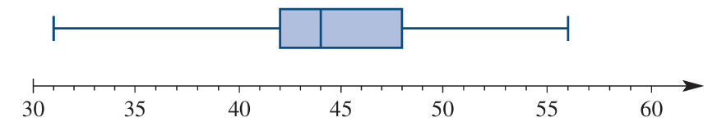
- The results of an assignment are represented in the following box plot.

  - Find the interquartile range.
48 – 42 = 6
  - What are the upper and lower limits for outliers?
Upper: 48 + 9 = 57
Lower: 42 – 9 = 33
  - Are there outliers in this dataset?
Yes, since the dataset goes down to 31.
- 2021 HSC Standard 2 Band 4
The five-number summary of a dataset is given.
Lowest score = 1, Lowest quartile = 4, Median = 7, Upper quartile = 10, Highest score = 20
Is 20 an outlier? Justify your answer with calculations.

Yes, 20 is greater than the upper fence of 19.
- 2023 HSC Standard 1
Consider the following dataset 22, 27, 29, 32, 36, 37, 39, 45, 47, 58
Is 58 an outlier in this dataset? Justify your answer with working.

No. It is less than the upper fence of 69.

Development
- 2019 HSC Standard 2 Band 4
The heights, in centimetres, of 10 players on a basketball team are shown.
170, 180, 185, 188, 192, 193, 193, 194, 196, 202
Is the height of the shortest player on the team considered an outlier? Justify your answer with calculations.

Yes. 170 is less than the lower fence of 171.5.
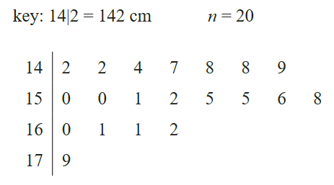
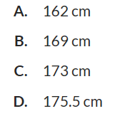
- HSC Standard 2 Sample Question Band 4
The stem plot below shows the height, in centimetres, of 20 players in a junior football team.
A player with a height of 179 cm is considered an outlier because 179 cm is greater than:

Upper fence is 175.5 cm
D

- 2015 HSC Standard 2 Band 5
In a small business, the seven employees earn the following wages per week:
$300 $490 $520 $590 $660 $680 $970
  - Is the wage of $970 an outlier for this set of data? Justify your answer with calculations.
List of wages (ordered): 300,490,520,590,660,680,970
Q1: 490
Q3: 680
IQR: 190
To check for upper outliers, compute the upper fence:
$$\begin{matrix}\text{Upper fence} & =Q_{U}+1.5×IQR \\ & =680+1.5(190) \\ & =680+285 \\ & =965\end{matrix}$$Since $970>965$, the wage of $970 is an outlier.
  - Each employee receives a $20 pay increase.
What effect will this have on the standard deviation?

No effect. The spread does not change.

Mastery
- 2017 HSC Standard 2 Band 5
A set of data has a lower quartile (Q_{L}) of 10 and an upper quartile (Q_{U}) of 16
What is the maximum possible range for this set of data if there are no outliers?
First, find the interquartile range (IQR):
$$\begin{matrix}IQR & =Q_{U}-Q_{L} \\ & =16-10 \\ & =6\end{matrix} \\ To have no outliers, the minimum and maximum data values must lie within the outlier boundaries. \\ \begin{matrix}\text{Lower bound} & =Q_{L}-1.5×IQR \\ & =10-1.5(6) \\ & =10-9 \\ & =1 \\ & \\ \text{Upper bound} & =Q_{U}+1.5×IQR \\ & =16+1.5(6) \\ & =16+9 \\ & =25\end{matrix} \\ To maximise the range without outliers, the minimum score can be 1$$ and the maximum score can be $25$.
$$\begin{matrix}\text{Maximum Range} & =25-1 \\ & =24\end{matrix} \\ The maximum possible range is 24$$.

- The interquartile range of a set of data is 10. If there are no outliers in this dataset, what is the largest possible range?

all values lie within [Q1 − 15, Q3 + 15].
The range within those fences is:
(Q3 + 15) − (Q1 − 15) = IQR + 30 = 40

